NOS 120 Journal

Ubuntu 10.04

This document is a periodical listing of all assignments and instructions completed in the NOS 120 class.

2011

Table of Contents:

**Table of Contents ………………………………………………………………………………………………………………………………… 2**

**Table of Contents (cont.) …………………………………………………………………………………………………………………….. 3**

**Course Syllabus ……………………………………………………………………………………………………………………………………. 4**

**Journal Post (8/17) ……………………………………………………………………………………………………………………………… 13**

**Chapter 1 Questions …………………………………………………………………………………………………………………………… 14**

**Journal Post (8/24) ……………………………………………………………………………………………………………………………… 16**

**Chapter 2 Questions ……………………………………………………………………………………………………………………………. 17**

**Journal Post (9/7) ………………………………………………………………………………………………………………………………… 18**

**Chapter 3 Questions ……………………………………………………………………………………………………………………………. 19**

**Journal Post (9/12) ……………………………………………………………………………………………………………………………… 20**

**Chapter 4 Questions …………………………………………………………………………………………………………………………… 21**

**Chapter 5 Questions …………………………………………………………………………………………………………………………… 23**

**NOS 120 Test 2 …………………………………………………………………………………………………………………………………… 24**

**Linux File System vs. Windows File System …………………………………………………………………………………………. 27**

**Journal Post (9/14) ……………………………………………………………………………………………………………………………… 28**

**10.04 Sources List ………………………………………………………………………………………………………………………………. 29**

**Things to do after installing Ubuntu 10.04 …………………………………………………………………………………………. 37**

**Journal Post (9/21) …………………………………………………………………………………………………………………………….. 45**

**How to make Ubuntu look like a Mac ………………………………………………………………………………………………… 46**

**Journal Post (9/28) …………………………………………………………………………………………………………………………….. 50**

**Journal Post (10/6) ……………………………………………………………………………………………………………………………… 51**

**Journal Post (10/8) ……………………………………………………………………………………………………………………………… 52**

**Journal Post (10/11) ……………………………………………………………………………………………………………………………. 53**

Table of Contents (cont.):

**Journal Post (10/17) ……………………………………………………………………………………………………………………………. 54**

**Journal Post (10/19) ……………………………………………………………………………………………………………………………. 56**

**Journal Post (10/24) ……………………………………………………………………………………………………………………………. 57**

**Things to do after installing Ubuntu 11.10 ………………………………………………………………………………………….. 58**

**(Corrected) Things to do after installing Ubuntu 11.10 ……………………………………………………………………….. 71**

**Journal Post (11/2) ………………………………………………………………………………………………………………………………. 75**

**Inkscape assignment …………………………………………………………………………………………………………………………….. 76**

**Journal Post (11/7) ……………………………………………………………………………………………………………………………….. 77**

**Linux Mint Project …………………………………………………………………………………………………………………………………. 78**

**Linux Mint Assignment ………………………………………………………………………………………………………………………….. 83**

**Changing Desktop Appearance no Linux Mint 11 (Advanced) ………………………………………………………………. 92**

**Linux Mint Advanced Desktop (Results) ……………………………………………………………………………………………….. 107**

**Journal Post (11/28) ………………………………………………………………………………………………………………..……………. 108**

**Journal Post (11/30) ………………………………………………………………………………………………………………….….………. 109**

Course Syllabus

|  |  |
| --- | --- |
| **Session and Year:** | Spring 2011 |
| **Course Name:** | NOS-120 – Linux Unix Single User |
| **Instructor Information:** | Carl Lewis |
|  | Office: Finch 123 |
|  | Office Hours: Monday and Wednesday 10:00 – 10:55  Tuesday and Thursday 10:00 – 12:55 |
|  | Other Hours By Appointment |
|  | Phone: 336-249-8186, Ext. 6363 |
|  | E-mail: cwlewis@davidsonccc.edu |
| **School Contact Information:** | Bob Sweet, Associate Dean, 336-249-8186, Ext. 4787 OR  Randy Ledford, Dean, 336-249-8186, Ext. 6357  Allison Palmadessa Assistant Dean, 336-249-8186 Ext. 6155  School of Business, Engineering, & Technical Studies  E-mail: rgsweet@davidsonccc.edu or [rledford@davidsonccc.edu](mailto:rledford@davidsonccc.edu) or apalmade@davidsonccc.edu |
| **Online Course Information:** | http://blackboard.davidsonccc.edu |

**Course Description:**

Prerequisites: **I**  SEC 110 and NET 110 or NET 125

Lecture: 2 Lab: 2 Credit: 3

This course develops the necessary skills for students to develop both GUI and command line skills for using and customizing a Linux workstation. Topics include Linux file system and access permissions, GNOME Interface, VI editor, X Window System expression pattern matching, I/O redirection, network and printing utilities. Upon completion, students should be able to customize and use Linux systems for command line requirements and desktop productivity roles.

Upon successful completion of this course, the student will be able to:

|  |
| --- |
| * Successfully install Ubuntu Desktop Operating System. * Develop GUI and command line skills for using and customizing a Linux workstation. * Become familiar with the GNOME Interface. * Be able to setup Linux file system and access permissions. * Become familiar with the VI editor. * Become familiar with the X Window System expression pattern matching, I/O redirection,   network and printing utilities.   * Students should be able to customize and use Linux systems for command line requirements   and desktop productivity roles. |

**Required Text:**

Title: A Practical Guide to Ubuntu Linux

Author: Mark Sobell

Publisher: Pearson Education

**ISBN-13:** 978-0-13-254248-7

**Required Material**:

Minimum 8 GB Flash Drive or Portable Hard Drive

**Methods of Instruction:**

Major teaching strategies will include text assignments, case problems, problem-solving activities, classroom discussions and projects. Students are expected to communicate in classroom setting and via Discussion Board forums and Blackboard Communication Tools. Students should participate in all class discussions and should prepare themselves by completing all required reading assignments.

Hands-on computer exercises and problem-solving activities will allow students to learn and practice the skills needed to secure network systems and develop policies to implement security controls. Individualized assistance on assignments, demonstrations, and explanations are available in the computer coaching center, and with the instructor by appointment.

**Grading Information and Policy:**

The following grading scale will be used to determine your final grade for this course:

A = 90 − 100

B = 80 − 89

C = 70 − 79

D = 60 − 69

F = below 60

Grades will be distributed as followed:

15% - Review Questions

15% - Projects

20% - Chapter Test

20% - Final Exam

10% - Quizzes

20% - Journals

Note: The final course grade will not be rounded or “curved”. If a student is within 0.5 points of the next higher letter grade the instructor, at their discretion, may reward the student with up to 0.5 points based on their participation in class during the semester. This policy does not guarantee the reward, as it is entirely the subjective judgment of the instructor.

**Assignment Due Dates:**

Make sure you check each due date and have it completed by that time. Most assignments will be required to be submitted no later than 11:55 PM on the date due. Understand if you procrastinate; it can cause you to receive a zero for an assignment. Be prepared!

**Makeup Tests:**

There will be no make-up testing unless notification has been given to the instructor prior to the due date. If a test will be missed, official documentation explaining the absence must be presented to the instructor before any test is rescheduled.

Otherwise, students will NOT be allowed to make up tests. If prior notification is not given and a student misses one test, then at the end of the semester the lowest test grade will replace that one missed test grade. If a second test (or more) is missed or not completed without prior notification, a zero (0) will be assigned for that test grade.

If the Final Exam is not completed by the posted due date, a zero (0) will be assigned for that grade as well.

**Late Assignments:**

Late assignments will NOT be accepted. Any work not submitted by the indicated due date and time will result in a grade of zero (0).

**Reading Assignments:**

Students are responsible for all material in the textbook and any other reading assigned by the instructor. Expect quizzes.

**Attendance:**

According to the campus-wide attendance policy, “The College believes that in order for students to be academically successful in achieving their educational goals, they must participate in all scheduled class sessions, laboratories, and clinical meetings. Although the occasional absence may be unavoidable, students are responsible to demonstrate their commitment to their educational goals by contacting their instructor to determine if arrangements can be made to make up any missed work.

Students are expected to be in attendance at least 90% (58 hours) of all scheduled class hours (64 hours). In the event that a **student’s absences in a course exceeds 10%** (**6 hours or 3 class meetings**) of the scheduled class hours **and the absences are not justified**, **prior to or on the 75% point of the semester, the instructor will subtract one letter grade from the final grade for each additional class missed.** **If a student’s absences exceed 10% of the scheduled class hours after the 75% point of the semester, the student will receive a grade of WF for the course.** Class attendance is calculated from the first officially scheduled class meeting through the last scheduled class meeting.”

Attendance will be checked daily during the first five minutes of class. **Any student who enters class after attendance has been taken or leaves class early will be counted tardy**. **Two** tardies count as one day of absence. ***The lowest quiz grade will be dropped if two (2) classes or fewer are missed and if all quizzes are completed!***

I will check the class roll twice during each class session.

**Journal Assignment:**

The following rubric will be used in grading the journal. You will be given 10 to 15 minutes per class to record the events of that day for your daily log. There will be obvious troubleshooting entries along with the actual labs you are working. If you use vague entries such as “Worked in lab, had problems but fixed them”, your entry will not be accepted. I expect at least one page typed information for each day of class.

**Journal**

Each student will keep a journal of all work completed during the semester coupled with all materials covered. It consists of a folder or binder for each individual in the class, which contains the entirety of that student’s work for the project. Consolidating each student’s work in a single place allows for easy collection of assignments, and gives students responsibility for keeping his or her own material organized.

I have a digital copy of a good journal and will allow students to view it for an example of what is required.

**Assessment**

The Journal itself will be graded based on completeness and organizational skills. A complete journal will include:

* All class handouts, including syllabus and assignment sheets
* All teacher-assigned work (homework, quizzes, etc.)
* Daily logs, one per day of independent work
* All major project information used in the collection of information. In example, what sources did you use in the collection of data?

**Group meeting notes**

* All documents in the journal should be organized by date
* Students should be responsible for lost, damaged, or poorly kept Journals or points will be deducted for journals that are: **- Lost** (no credit for assignments that are lost!) **- Damaged** or **sloppy** (unprofessional!)
* At the end of the semester the students will hand in their journals for grading. Date will be announced by the instructor.
* Journal contents will be graded and returned prior to the last class meeting
* Notes and logs are a student’s evidence of work done on a daily basis.
* One of the reasons a journal is used is to improve work habits, teamwork, effective use of time, and good planning and preparation.

**Withdrawing From This Course:**

The following policies are in effect if a student considers withdrawing from this course.

* Up to the 10% date a student may withdraw without an assigned grade.
* Between 10% and 75% date a student may withdraw with an assigned grade of W. This can be student initiated or instructor initiated. This grade will appear on transcripts.
* After 75% date a grade must be assigned.
* A student may choose to change a course to an audit grade up to the 75% date with permission of the instructor.
* If a student stops attending after the 75% point of the semester, the instructor may assign a grade of “WF.” The grade of “WF” indicates that the student is failing at the time of non-attendance and will count the same as an “F” in the student’s GPA calculation.

**Academic Integrity Policy:**

Students are expected to conduct themselves according to generally accepted standards of scholarship The faculty of the College is committed to helping students reach their full academic potential and to preparing them for success in their careers and further academic pursuits. Therefore, the College is committed to fostering a learning environment where students perform to the best of their own abilities and where academic integrity and honesty pervades.

True intellectual growth is dependent upon honest work. As scholars, Davidson County Community College students are expected to demonstrate integrity in all of their academic pursuits by doing their own work, without unauthorized assistance from others. **The College will not tolerate academically dishonest acts such as, but not limited to, cheating, fabricating, plagiarizing (including multiple submissions of one’s own work), and/or assisting others in academically dishonest acts.**

**Cheating i**s defined by the College as gaining or receiving unauthorized help during any academic assignment including using or attempting to use **unauthorized:**

* information (e.g. notes, someone else’s work, test bank information),
* communication (e.g. talking, writing, or signing/signaling others),
* electronic devices (e.g. cell phones, blackberries, mp3 players, calculators, digital recorders/cameras, or other data storage device) during any academic assignment or test.

**Fabricating** is defined as generating false data, sources, or citations for any academic assignment.

**Plagiarizing** includes any attempt to pass another’s work off as one’s own, in part or in whole, without properly acknowledging the source. This includes directly quoting, summarizing, or using ideas, images, or data from another’s work without properly citing the source as well as submitting purchased or borrowed papers as one’s own. **Submitting one’s own identical work for multiple assignments is prohibited without instructor permission.**

**Assisting others in academically dishonest acts** includes any activity that is intended to help another person cheat, fabricate, or plagiarize. These acts include but are not limited to allowing another to copy work, providing test questions or answers, unsanctioned collaboration, and completing an academic assignment for someone else.

***NOTE: Any person demonstrating academic dishonesty in this course (whether on the giving or the receiving end) will be subject to disciplinary action resulting in a grade of zero (0) for that assignment in which academic dishonesty has been documented. If there is a second occurrence of dishonesty, the person(s) involved will be assigned a grade of F for the course.***

Students who remain enrolled and engaged in courses beyond the review of the syllabus are considered to have read and agree to both the College’s policy and the academic penalties which may be invoked. **Academic penalties for violation of the policy can and may be applied differently by the faculty of the College.**

Assessing the academic work of students is the purview of the instructor; therefore, issues regarding academic dishonesty should be resolved between the instructor and the student. However, any unresolved issues will be referred to the appropriate Academic Dean for further review. On the rare occasion when resolution is still unreachable, the infraction may be referred to the Vice President for Academic Programs and Services. The Vice President’s decision will be final.

**Please Note: Violation of the Academic Integrity policy is a violation of the Student Code of Conduct.** As outlined in the DCCC Student Code of Conduct, academic dishonesty is strictly prohibited. Students who violate the academic integrity policy will be reported to the Dean of Student Services. V**iolations may also result in the Dean issuing additional sanctions, up to and including expulsion, as outlined in the Student Code of Conduct.**

**Access to Academic Support Services:**

Upon request, the Learning Assistance Center (LAC) provides free tutoring services to currently enrolled students. Students needing specialized academic support in writing, math, accounting, or computing, can also seek out assistance from the Writing Center, Math Coaching Center, or Business and Computer Coaching Center (Finch 102).

**Assistance for Students with Disabilities:**

The College intends that all courses of study be fully accessible to all qualified students. Reasonable accommodations for verified disabilities are available upon request. Students must take the responsibility to make their disability known and request academic accommodations or auxiliary aids. Requests for information and assistance should be made to the Mental Health and Disabilities Counselor in Brooks Student Center room 207.

**Policies regarding Technology:**

**Technology in the Classroom:**

The faculties at DCCC are committed to the integration of technology into the classroom. This may include but is not limited to smart rooms, laptop computers, document cameras, hand held data collection devices and use of Blackboard internet technology for supplementation of classroom activity.

**Computer Usage Policy:**

Responsible ethical behavior is expected of persons using computing resources. Students are expected to adhere to guidelines published in the DCCC College Catalog.

Six basic rules that ***MUST*** be followed when using the computers in this course include:

1. During Lab hours, any person caught playing games, using Facebook, or anything other than the assignment will receive a grade of zero for that Do Not Play Games of Any Kind, including Solitaire, at ANY TIME
2. Do Not Bring Food or Drinks into the Lab
3. Do Not Use the Computer for Chat sessions– *EVER*!
4. Do Not Visit/Download from websites not authorized by the instructor.
5. Never use portable electronic devices of any kind while in class or lab. Ensure all phones are either off or in vibrate mode.
6. You will be actively proactive in all lab and case study assignments.

# Cell Phones, Pagers, & Other Electronic Devices:

Classrooms should be free of all unnecessary distractions from the task of learning. Therefore, as a general rule, **students should turn off all personal electronic devices not being used for coursework prior to entering the classroom**. Instructional management is a right and a responsibility of the instructor, therefore, policy regarding the use of electronic devices in the classroom may vary depending upon the nature of the course or the guidelines of the instructor.

**Learning Commons:**

The new Learning Commons is located on the first floor of the LRC. Please visit for your tutorial needs. Any tutoring regarding computer systems, math, and many more are located there. In addition there are many computers available for your use.

**Code of Conduct:**

Please review pages 42 through 53 of the DCCC catalog.

**College Competencies:**

|  |  |
| --- | --- |
| **Davidson County Community College**  **Learning Competencies**  Davidson County Community College requires each degree-earning student to demonstrate mastery of content relative to their unique field of study as well as DCCC’s Learning Competencies. A learning competency is a skill that enables student success in a professional setting and in education opportunities throughout life. What follows is a list of learning competencies with equal emphasis placed on all competencies. | |
| **Communication Skills: Communicate effectively by listening, speaking, and writing.** | |
| Examples of Student Skills:   * *Use context appropriate grammar* * *Use appropriate vocabulary* * *Listen for main ideas* * *Follow directions* * *Conduct interviews* * *Demonstrate civility* * *Deliver clear, well-organized verbal presentations* * *Write effective papers, reports, memos, letters, etc.* | Some Examples of Student Work:   * *Research projects or papers* * *Verbatim, analysis of interviews* * *Presentations* * *Professional letters, reports, memos, etc.* * *Group project and/or presentation* |
| **Critical Thinking: Think critically to analyze and solve problems** | |
| Examples of Student Skills:   * *Identify problems* * *Identify patterns, inferences, or ambiguity in a line of reasoning* * *Formulate potential outcomes* * *Develop solutions* * *Evaluate results* * *Apply mathematical reasoning to the discipline of study* * *Manage conflict* * *Develop goals* * *Choose ethical course of actions* | Some Examples of Student Work:   * *Case studies* * *Problem-based learning activities* * *Work place simulations* * *Short-term and long-term student goals* |
| **Information Literacy: Identify, locate, evaluate, and use information effectively** | |
| Examples of Student Skills:   * *Identify information needs* * *Locate, retrieve, and evaluate information* * *Use electronic and print resources* * *Use information technology effectively and ethically to accomplish a specific purpose* | Some Examples of Student Work:   * *Case studies* * *Problem-based learning activities* * *Research projects or papers* * *Educational materials for discipline of study* |
| **Cultural Literacy: Observe, analyze, and participate effectively in the diverse human experience** | |
| Examples of Student Skills:   * *Identify student’s own cultural heritage* * *Research other cultures* * *Practice civility toward people of different cultures* * *Interact appropriately and effectively with people of other cultures* * *Identify and avoid culturally discriminating language* * *Demonstrate appropriate work place skills* * *Identify self as a world citizen* | Some Examples of Student Work:   * *Clinical experiences* * *Research projects* * *Participation in community events* * *Peer mentoring* |

Journal Post (8/17/2011)

Today was the first day of class. We went over the class syllabus as well as what will be required of us in the class and labs. We briefly discussed the history of Linux and some of the applications we will be using and implementing in the labs throughout the semester. We also received our hard disk drives to install Ubuntu 10.04 on and discussed the process on doing the install and what to pay attention to.

NOS 120 (Chapter 1 End of Chapter Questions)

1. What is free software? Software that can be used, studied, and modified without restriction, and can be copied and redistributed in modified or unmodified form.

List three characteristics of free software. Free to study it, free to redistribute it and free to modify it as a result the code is free of cost for software, source, documentation and support.

1. Why is Linux popular? It is open source; you can download Linux for free and customize to your needs. The software is adaptable with a large amount of libraries and utilities

Why is it popular in academia? It’s free, fast, reliable and stable.

1. What are multiuser systems? An operating system that allows many people on many different computers to use and do the same tasks at the same time

Why are they successful? They limit the amount of resources needed to operate many user accounts which save on cost

1. What is the Free Source Foundation/GNU?

What is Linux? A UNIX like system that uses a Linux kernel

Which parts of the Linux operating system did each provide?

Who else has helped build and refine this operating system?

1. IN which language is Linux written? 95% of the language is C programming

What does the language have to do with the success of Linux? Because the C programing language is portable this allows Linux to be run on many different machines.

1. What is a utility program? A program that performs a specific task related to the management of computer functions, resources and files.
2. What is a shell? An interrupter

How does it work with the kernel? It holds functions in memory so it does not have to read from disk every time you execute

With the user? Allows users to work on different applications back and forth as needed

1. How can you use utility programs and a shell to create your own applications? Using the command line with filters
2. Why is the Linux file system referred to as *hierarchical*? It arranges file in directories and organizes them in a tree like form
3. What is the difference between a multiprocessor and a multiprocessing system?

A multiprocessor is a processor or CPU that performs more than one task at a time/ A multiprocessing system is a computer that has more than one CPU

1. Give an example of when you would want to use a multiprocessing system? When you want to keep your user accounts separated
2. Approximately how many people wrote Linux? Linus Torvalds

Why is this project unique? Allows applications to run with any OS

1. What are the key terms of the GNU General Public License? Gives you the right to modify the code and when you redistribute the code you have to use the same license as you modified originally

Journal Post (8/29/2011)

Today we went over the sources.list, which are files from different services that are accessed from servers around the world. We also discussed how to change to the root user in Ubuntu and set permissions in the directories.

“#” = The text not being read by the computer

<http://rtfq.net> = the website created by Carl for the Linux students to access for help with the projects

sudo = emulates root user

sudo gedit /etc/apt/sources.list > is the file path to sources.list

“sudo password root” = root password

$ = regular user

Su to enter root admin. / # = super user

#chmod 777 –R /etc/apt > gives you the permission rights to change the files in those directories

r = read

w = write

x = execute

NOS 120 (Chapter 2 End of Chapter Questions 1-9)

1. Briefly, what does the process of installing an operating system such as Ubuntu Linux involve?

Copy the operating system files from a CD, DVD, or USB drive to a hard drive, then set up the configuration files to operate with the hardware you have.

1. What is an installer?

It is graphical tool that aids you in the installation process and also allows you to customize the OS to the user’s needs. Helps in planning with partitioning the hard drive, getting the files for the install and creating a CD or DVD.

1. Would you set up a GUI on a server system? Why or why not?

No, because the GUI will slow down the processes being performed.

1. A system boots from the hard disk. To install Linux, you need it to boot from a CD/DVD. How can you make the system boot from a CD/DVD?

You have to access the BIOS utility setup immediately after startup and browse to the menu to change the boot sequence order and specify the CD/DVD is listed first.

1. What is free space on a hard disk? What is a file system?

Free space is a disk with no partitions or partition table.

A file system is a way to organize and save data for a program after it is shut down.

1. What is an ISO image? How do you burn an ISO image to a CD? DVD?

International Organization for Standardization = a file or disc image written on an optical disc that burns the data to every sector of the optical disk.

Find the ISO image you are wanting to burn and open it with a write image or burn image option from the CD/DVD burning software and install a CD or DVD into the drive bay.

1. Give two reasons why RAID cannot replace backups.

First both disks can be damaged at the same time due to fire or electrical voltage.

Second it will not protect to data if the user accidently erases the data.

1. What are RAM disks? How are they used during installation?

A RAM disk is primary storage or volatile memory that is erased when shut down but keeps all applications in storage while you are working on them for fast and easy access.

1. What is SHA1? How does it work to ensure that an ISO image file you download is correct?

Secure Hash Algorithm

When you download software from a secure cite an algorithm is given to the software with the size of the package and it must match the algorithm on the client computer to verify no data was compromised upon delivery.

Journal Post (9/07/2011)

Today we had a review of the chapter questions.

In lab today we installed XBMC an open source media center using the terminal.

Listed here are the terminal commands used:

sudo apt-get install python-software-properties pkg-config

sudo add-apt-repository ppa:team-xbmc

sudo apt-get update

sudo apt-get install xbmc xbmc-standalone

sudo apt-get update

sudo apt-get install libvdpau1 nvidia-185-libvdpau

deb http://ppa.launchpad.net/team-xbmc/ppa/ubuntu jaunty main

deb-src http://ppa.launchpad.net/team-xbmc/ppa/ubuntu jaunty main

sudo apt-key adv --recv-keys --keyserver keyserver.ubuntu.com 0x6d975c4791e7ee5e

Chapter 3 Questions 1-8

1. How do you start a live session? Boot the system from the live/install CD, not pressing in keys wait for the system to boot.

List two problems you could encounter and explain what you would do to fix them. The BIOS may not be set for CD/DVD boot- you need the change the order in which the CD/DVD will be the first option. Display problems – simply reboot the system.

1. What steps should you take before you start a live session the first time or install Ubuntu with a new CD/DVD? Check to make sure there are no defects to the CD and make sure the contents are verified before install.

How would you do it? Select the tab for **Check disc for Defects** in the CD menu screen.

1. What is guided partitioning? It divides the hard drive into multiple partitions using available space and usage patterns.
2. What is ubiquity? A graphical live CD installer designed to integrate with Debian - and Ubuntu-based systems
3. Describe the ubiquity partition editor. It creates two partitions on the hard disk a swap partition and a root partition.  
   How does it differ from the partition editor found on the Alternate and Server CDs?

It starts to partition immediately where the ubiquity asks you before the start of the partitioning.

1. When is it beneficial to use an ext2 file system instead of an ext4 file system? Only when you are sharing the file system with another Linux machine that is using an older file system.
2. What is a virtual console? A process that allows you to do two activities in parallel.  
   During installation, for what purposes can you use a virtual console? To help you diagnose installation problems.  
   If the system is displaying a virtual console, how do you display the graphical installation screen instead? By pressing CONTROL-ALT-F1.
3. What steps would you take to have the system display all the things it is doing as it boots from a live/install Desktop CD/DVD? Delete the quit and splash in the boot command line, then press enter.

.

Journal Post (9/12/2011)

Today we installed Ubuntu on a USB stick.

To help with the installation we used a program called unetbootn to load the iso and make the USB stick bootable.

I used a 8Gb flash drive which I made with 7364Mb of persistence.

All installation worked great and the operating system booted perfectly.

This is a great item to have, a traveling OS so you can take all your work, school, or personal files with you wherever you go.

NOS 120 – Chapter 4 – Questions

1. The system displays the following message when you attempt to log in with an incorrect username *or* an incorrect password:

*Login incorrect*

1. This message does not indicate whether your username, your password, or both are invalid. Why does it not reveal this information? It is a strategy meant to discourage unauthorized people from guessing names and passwords to gain access to the system.
2. Why does the system wait for a couple of seconds to respond after you supply an incorrect username or password? To help stop a brute force attack from cracking the system security features.
3. Give three examples of poor password choices. What is wrong with each?  
    **Baseball2 =** word in the dictionary easily can use a dictionary attack to crack

**hjsueytwn** does not contain a number or a capitalized letter

**8wer** is short for a passwordtoo short

1. Is **fido** anacceptablepassword? Give several reasons why or why not.  
   No, a password needs to be at least 8 characters with at least one number so it will not be easily guessed.
2. What is a context menu? It is a menu with choices that apply to the window or icon you click on. How does a context menu differ from other menus? It is specific to what you previously right clicked on – like an extension of the previous page with more options.
3. What appears when you right –click the root window? Displays the desktop menu. How can you use this object? Enables you to create a folder, launcher, or document.
4. How would you swap the effects of the right and left buttons on a mouse? (Main menu: System>Preferences>Mouse) then specify the change of position between the right and left function. What is the drag-and-drop threshold? Specifies how far you must drag an object before the system considers the action apart of the drag and drop option. How would you change it? Change the characteristics in the Mouse Preferences window.
5. What are the primary functions of the Main menu? It is to organize the types of applications that are possible between the user and the computer.
6. What is the input focus? A window that receives keyboard input. When no window has the input focus, what happens to the letters you type on the keyboard? The keyboard input is lost. Which type of input focus would you prefer to work with? Why? Click-to-focus gives you the input to a window when you click the window.
7. What are the functions of a Window Operation menu? Contains operations that you most commonly need to perform on any window. How do you display this menu? Right-click either the tool bar or the Window List applet will display the menu.
8. What is a panel? It is the strip at the bottom of the screen like the task bar in Windows. Name a few objects on the panel and explain what you can use them for. Blue and orange globe = starts Firefox, envelope starts Evolution; the objects start applications and programs. What do the Workspace Switcher applet and the Window List applet do? Workspace Switcher applet is the rectangular shapes at the bottom right of the desktop, they identify the different workspaces and highlight which one is in current use / Window List applet appears at the bottom of the panel – left click minimizes and restores the size of the workspace, right click displays the Windows Operations menu.
9. What are tooltips? How are they useful? A mini-context help system that you activate by moving the mouse pointer over a button, icon, window border, or applet / it gives you a brief explanation of the object.

NOS 120 – Chapter 5 – Questions

1. **Which commands can you use to determine who is logged in on a specific terminal?  
   *finger, w, who, whoami, who am i***
2. **How can you keep other users from using write to communicate with you? Why would you want to? By using the mesg n command it will prevent users from having the write to communicate. You would use this if you did not want to be disturbed or to prevent overwriting on your screen.**
3. **What happens when you give the following commands if the file named done already exists?**

***$ cp to_do done Will make a copy of the file done a name it to_do  
$mv to_do done Will replace the done file done and erase the original and name it to_do***

1. **How can you find out which utilities are available on your system for editing files? Which utilities are available for editing on your system? Use the command apropos editor / vim, ex, ed**
2. **How can you find the phone number for Ace Electrics in a file named phone that contains a list of names and phone numbers? grep “Ace Electronics” phone Which command can you use to display the entire file in alphabetical order? sort phone $How can you display the file without any adjacent duplicate lines? uniq phone How can you display the file without any duplicate lines? sort –u phone**
3. **What happens when you use diff to compare two binary files that are not identical? (You can use gzip to create the binary files.) Explain why the diff output for binary files is different from the diff output for ASCII files. It displays the differences between the two files comparing the versions of the source code. The ASCII files are compared line-by-line while the binary files are compared byte-by-byte.**
4. **Create a .plan file in your home directory. Does finger display the contents of your .plan file? In most version of Linux the finger command will show the contents of whatever is fingered in their home directory.**
5. **What is the result of giving the which utility the name of a command that resides in a directory that is not in your search path? It will show a command not found error - It will only display results from the directories in your search path and displays only the first one.**
6. **Are any of the utilities discussed in this chapter located in more than one directory on the local system? If so, which ones? No, but some commands that are built into a shell have an executable counterpart that exists as a file like echo.**
7. **Experiment by calling the file utility with the names of files in /usr/bin. How many different types of files are there? Around 24**
8. Which command can you use to look at the first few lines of a file named status.report? Which command can you use to look at the end of the file?  
   head status.report / tail status.report







[Linux Hierarchical File System](http://www.debianadmin.com/linux-directory-structure-overview.html) vs. [Windows NTFS File System](http://www.ntfs.com/)

There are many different file systems that are created for the different platforms of operating systems. Linux uses the [Linux Hierarchical File System](http://www.debianadmin.com/linux-directory-structure-overview.html) while Microsoft XP, Vista and Windows 7 use the [Windows NTFS File System](http://www.ntfs.com/). There are a few differences between the two filing systems with one major difference in the Linux HFS does not use named root drives, the root is listed as a forward slash “/” where Microsoft operating systems name each drive upon startup. The root drive in Microsoft operating systems is listed as “C:” which is the main hard drive where all other directories are listed under. The components of a path in the Linux filing system is differentiated by the use of forward slashes so you can tell which operating system you are using by the organization of the file path. The file path in Linux can also give you pertinent information such as the partition, or drive/device, or network device or an ordinary directory that is being used. The partitions or devices are not displayed in the file system unless they are mounted which is to put them into the filing system in a specific location of the directory tree. A normal user in Linux cannot access the partitions or devices without them being mounted first which most are done so automatically under system startup. The mounting of the partitions or devices are actually very flexible and allows you to mount a directory on another machine in the network and access it as if it were your own local machine.

Another difference in the file systems is in the Linux HFS all files and directories are case sensitive which allows more files to be saved with the same name altering a letter but can be hard to keep up with if you want to access a file and do not know the exact case of the letters. In Linux not all files will have a file extension listed in the path unlike Microsoft such as the .txt file extension. Both file systems allow you to hide files from users, in the Linux file system you put a dot in front of the file name to hide it. Linux is a multiuser system so all files belongs to a certain user or group. Only the owner of a file can let or grant access to other users to be able to use the file. Both file systems operate with read, write, and execute permissions with the read permission having to be allowed to access the file.

The file system structure is somewhat different, both use a tree format structure but the directories are very different by name and operation. In Microsoft the root is “C:\” with directories like “system”, “user”, “windows”, “temp”, and “program files” are the next level which are the directories in the root folder. In Linux the root is simply “/” with directories such as “/bin”, “/etc”, “/boot”, and “/dev” to name a few of the main directories. Each user in Linux is given a home directory where they can store files in any directory of their chose and can modify the system to meet their needs. All Linux and UNIX use the same file system structure to make all the operating systems of those two platforms standardized which makes it easier going from different operating system platforms. This also allows the user to modify and change the filing system to their personal needs due to the open source nature of the file system in Linux unlike the Windows NTFS File System. The Linux filing system offers many more advantages over the Microsoft filing system and costs a whole lot less; it’s FREE.

Journal Post (9/14/2011)

Today we went over file commands, how to create them and move them.

-touch >> command that creates a file

Touch poem = a file named poem

-vim >> text editor that will open a file

Vim poem = will show contents of the file poem in a text editor

-mv >> command that move a file to a new location

-cat >> command that will show what is in a file

-cp >> command can rename a file or copy to another directory

-mkdir >> command creates a directory

**linuxalt.com >>>>website that shows opensource compared to pay apps

cat /etc/sources.list >> path to sources

cat >> lets you look at the contents of the sources.list file

apt-get install >> lets you install a program with all the dependancies

apt-get remove >> lets you remove a program and all its dependancies

10.04 Sources List

# Ubuntu Lucid Lynx 10.04 Sources list  
#  
# Repository List based on standard Lucid with many extra packages  
#  
# If you get errors about missing keys, lookup the key in this file  
# and run these commands (replace KEY with the key number):  
#  
# sudo apt-key adv –recv-keys –keyserver keyserver.ubuntu.com KEY

# Ubuntu supported packages  
deb http://archive.ubuntu.com/ubuntu/ lucid main restricted multiverse universe  
deb http://archive.ubuntu.com/ubuntu/ lucid-backports main restricted universe multiverse  
deb http://archive.ubuntu.com/ubuntu/ lucid-updates main restricted multiverse universe  
deb http://security.ubuntu.com/ubuntu lucid-security main restricted universe multiverse  
deb http://security.ubuntu.com/ubuntu lucid-proposed main restricted universe multiverse  
deb-src http://archive.ubuntu.com/ubuntu/ lucid main restricted multiverse universe  
deb-src http://archive.ubuntu.com/ubuntu/ lucid-backports main restricted universe multiverse  
deb-src http://archive.ubuntu.com/ubuntu/ lucid-updates main restricted multiverse universe  
deb-src http://security.ubuntu.com/ubuntu lucid-security main restricted universe multiverse  
deb-src http://security.ubuntu.com/ubuntu lucid-proposed main restricted universe multiverse

#Canonical Commercial Repository  
deb http://archive.canonical.com/ubuntu lucid partner  
deb http://archive.canonical.com/ubuntu lucid-backports partner  
deb http://archive.canonical.com/ubuntu lucid-updates partner  
deb http://archive.canonical.com/ubuntu lucid-security partner  
deb http://archive.canonical.com/ubuntu lucid-proposed partner  
deb-src http://archive.canonical.com/ubuntu lucid partner  
deb-src http://archive.canonical.com/ubuntu lucid-backports partner  
deb-src http://archive.canonical.com/ubuntu lucid-updates partner  
deb-src http://archive.canonical.com/ubuntu lucid-security partner  
deb-src http://archive.canonical.com/ubuntu lucid-proposed partner

#medibuntu  
# sudo apt-key adv –recv-keys –keyserver keyserver.ubuntu.com 2EBC26B60C5A2783  
deb http://packages.medibuntu.org/ lucid free non-free  
deb-src http://packages.medibuntu.org/ lucid free non-free

#PlayOnLinux  
deb http://deb.playonlinux.com/ lucid main

#opera  
# sudo apt-key adv –recv-keys –keyserver keyserver.ubuntu.com F9A2F76A9D1A0061  
deb http://deb.opera.com/opera/ lenny non-free

#google  
# sudo apt-key adv –recv-keys –keyserver keyserver.ubuntu.com A040830F7FAC5991  
deb http://dl.google.com/linux/deb/ stable non-free main

#Dropbox Official Source  
deb http://linux.dropbox.com/ubuntu karmic main

#Skype  
deb http://download.skype.com/linux/repos/debian/ stable non-free

Things to do after installing Ubuntu 10.04

**List of some things to do after you get Ubuntu installed.**

**1 – Expand the Software Repository List**

First of all, lets make Ubuntu “see” more packages. Go to the terminal and edit your sources.list with :

sudo gedit /etc/apt/sources.list

Here is the content of my sources.list which I think is quite complete to have all the necessary applications you could ever need. So delete the whole content of your sources list and replace it with the content of [mine](http://dl.dropbox.com/u/1402212/lucid.sources.list)

Save it. Now import the necessary repositories keys to avoid “aptitude” crying about some missing keys, go to the terminal and type:

sudo apt-key adv --recv-keys --keyserver keyserver.ubuntu.com DCF9F87B6DFBCBAE F9A2F76A9D1A0061 A040830F7FAC5991 2EBC26B60C5A2783

Get your system up to date with :

sudo aptitude update && sudo aptitude full-upgrade

Now all your programs will run on the last version.

**2 – Anti-Virus**

**Windows equivalent** : AVG AntiVirus, NAV, TrendMicro, F-Prot, Kaspersky, …

**Ubuntu equivalent** : ClamAV, Avast

**ClamAV**

sudo aptitude install clamav clamtk

Access it through System Tools → Virus Scanner .

**Avast**

wget http://files.avast.com/files/linux/avast4workstation_1.3.0-2_i386.deb && sudo dpkg -i avast4workstation_1.3.0-2_i386.deb

Access it through Accessories → avast! Antivirus .

**3 – Essential tools for compiling from sources**

sudo aptitude install build-essential checkinstall cdbs devscripts dh-make fakeroot libxml-parser-perl check avahi-daemon

**4 – Java runtime environment**

Java is a very important thing to install, now that many programs like Azureus need it to run. So type:

sudo aptitude install sun-java6-jre sun-java6-plugin equivs

**6 – Multimedia**

**Windows equivalent** : windows media player, real player, vlc, mplayer

**Ubuntu equivalent** : vlc, mplayer, helix player

To have Ubuntu playing all kinds of stuff, you need to install many codecs. So on the Terminal, type:

**\* Installing vlc and mplayer (plays almost everything):**

sudo aptitude install vlc mplayer

**\* Common packs**

sudo aptitude install non-free-codecs libxine1-ffmpeg gxine mencoder mpeg2dec vorbis-tools id3v2 mpg321 mpg123 libflac++6 ffmpeg libmp4v2-0 totem-mozilla icedax tagtool easytag id3tool lame nautilus-script-audio-convert libmad0 libjpeg-progs libmpcdec3 libquicktime1 flac faac faad sox ffmpeg2theora libmpeg2-4 uudeview flac libmpeg3-1 mpeg3-utils mpegdemux liba52-dev

**\* Gstreammer 0.10**

sudo aptitude install gstreamer0.10-ffmpeg gstreamer0.10-fluendo-mp3 gstreamer0.10-gnonlin gstreamer0.10-pitfdll gstreamer0.10-sdl gstreamer0.10-plugins-bad-multiverse gstreamer0.10-schroedinger gstreamer0.10-plugins-ugly-multiverse totem-gstreamer

**\* More programs**

sudo aptitude install gstreamer-dbus-media-service gstreamer-tools ubuntu-restricted-extras

**\* Enable dvd support**

sudo aptitude install libdvdcss2 && sudo /usr/share/doc/libdvdread4/./install-css.sh

**\* Flash**

sudo aptitude install gsfonts gsfonts-x11 flashplugin-nonfree

**7. Tweak your eyecandy**

Ubuntu 10.04 comes with compiz fusion effects OOTB but doesn’t offer a way to customize them.

In a terminal copy/paste this:

sudo aptitude install simple-ccsm

Now navigate to System → Preferences → Simple CompizConfig Settings Manager .

**8 – Missing Windows software?? Run Windows softwares in Linux!!!**

Run Windows Applications such as 7zip, Google Sketchup, AutoCAD, Dreamwaver, Flash MX, Fireworks MX, IE6, IE7, Safari, Itunes, Windows Media Player and many more…

Play Windows Games in Linux like Age Of Empires, Call Of Duty, Diablo, Fear, Fallout, Far Cry, Grand Theft Auto, Half Life, Halo, Hitman, Max Payne, Need For Speed, Prince Of Persia, Sim City Star Wars, The Simsworld of warcraft , Tomb Raider, Warcraft, World Of Warcraft, Counterstrike and many other can be played.

Install Playonlinux. It’s based on wine. Wine is a compatibility layer for running Windows programs in Linux.

sudo aptitude install wine playonlinux

**9 – Clipboard Management**

By Default in ubuntu when u copy something from an application and closes the application u will not be able to access it from the clipboard. And also when u copy severals text in serial u only have the last on available to you in the clipboard. To solve that install either of the following but Glipper is better because it supports plugins.

**Glipper**

sudo aptitude install glipper

Then right click ur panel → Add to Panel then drag Clipboard Manager to ur panel

**Parcellite**

sudo aptitude install parcellite

**10 – Archiver/ Packing software**

**Windows equivalent** : winrar, zip, 7zip

**Ubuntu equivalent** : tar, unrar, p7zip, arj, unace

It’s bad when you don’t have Internet on your computer/notebook, but you have to pack/unpack something but the file format isn’t recognized by the system. To prevent from this bad situation, you can install a bunch of packing software by typing this on the terminal:

sudo aptitude install unace rar unrar zip unzip p7zip-full p7zip-rar sharutils uudeview mpack lha arj cabextract file-roller

**11 – Graphical web browser**

**Windows equivalent** : Internet explorer, firefox, opera

**Ubuntu equivalent** : Firefox, opera, chromium

**Opera**

sudo aptitude install opera

**Firefox (installed by default intrepid)**

sudo aptitude install firefox

**Chromium (open source equivalent of Google Chrome)**

sudo aptitude install chromium-browser chromium-browser-l10n

**12 – Download Manager**

**Windows equivalent** : Free download manager

**Ubuntu equivalent** : Multiget

MultiGet is a http/ftp downloader with a nice GUI for linux desktop users. It can run on almost all desktops without any configuration. It has many powerful functions comparing to others.

sudo aptitude install multiget

Access it through Applications → Internet → MultiGet .

**13 – Graphical Email client**

**Windows equivalent** : Outlook

**Ubuntu equivalent** : Evolution, Thunderbird

**Evolution (installed by default in lucid)**

sudo aptitude install evolution

Access it through Applications → Internet → Evolution Mail .

**Thunderbird**

sudo aptitude install thunderbird

Access it through Applications → Internet → Mozilla Thunderbird Mail/News .

**14 – Instant Messanging protocal clients**

**Windows equivalent** : MSN messenger, Yahoo messenger, QQ, AIM, Gtalk, ICQ,IRC

**Ubuntu equivalent** : Empathy, Pidgin, emesene

**Empathy IM Client (installed by default)**

Add the related launchpad repository :  
sudo add-apt-repository ppa:telepathy/ppa && sudo aptitude update

Then install it by running the following :  
sudo aptitude install empathy telepathy-mission-control-5 telepathy-gabble telepathy-butterfly telepathy-haze telepathy-idle telepathy-salut telepathy-sofiasip libtelepathy-farsight0 python-tpfarsight galago-eds-feed python-galago python-galago-gtk msn-pecan

Access it through Applications → Internet → Empathy IM Client .

**Pidgin**

Pidgin is an easy to use and free chat client used by millions. Connect to AIM, MSN, Yahoo, and more chat networks all at once. Supported chat networks: AIM, Bonjour, Gadu-Gadu, Google Talk, Groupwise, ICQ, IRC, MSN, MySpaceIM, QQ, SILC, SIMPLE, Sametime, XMPP, Yahoo!, Zephyr

Add the launchpad repository :  
sudo add-apt-repository ppa:pidgin-developers/ppa && sudo aptitude update

Then install it :  
sudo aptitude install pidgin pidgin-data pidgin-lastfm pidgin-guifications msn-pecan pidgin-musictracker pidgin-plugin-pack pidgin-themes

Access it through Applications → Internet → Pidgin Internet Messenger .

**Emesene only for MSN Messenger.**

Add the launchpad repository :  
sudo add-apt-repository ppa:bjfs/ppa && sudo aptitude update

Then install it :  
sudo aptitude install emesene

Access it through Applications → Internet → Emesene .

**15 – VOIP**

**Windows equivalent** : skype

**Ubuntu equivalent** : skype

**Skype**

sudo aptitude install skype

Access it through Applications → Internet → Skype.

**16 – Viewing PDF files**

**Windows equivalent** : Adobe Reader

**Ubuntu equivalent** : Adobe Reader

**Adobe Reader**

sudo aptitude install acroread acroread-fonts

Access it through Applications → Office → Adobe Reader.

**17– Adobe Air**

wget http://airdownload.adobe.com/air/lin/download/latest/AdobeAIRInstaller.bin  
chmod +x ./AdobeAIRInstaller.bin

sudo ./AdobeAIRInstaller.bin

Access it through Applications → Accessories → Adobe Air Application Installer.

**18 – Music / MP3 / OGG Players**

**Windows equivalent** : iTunes, Winamp

**Ubuntu equivalent** : Rhythmbox, Banshee, Amarok

**Rhythmbox**

sudo aptitude install rhythmbox

Access it through Applications → Sound & Video → Rhythmbox Music Player.

**Banshee**

sudo aptitude install banshee banshee-extension-ubuntuonemusicstore libappindicator0-cil banshee-extension-appindicator banshee-extension-lyrics banshee-extension-mirage

Access it through Applications → Sound & Video → Banshee Media Player.

**Amarok**

sudo aptitude install amarok amarok-common

Access it through Applications → Sound & Video → Amarok.

**19– Hard Disk Partitions Manager**

**Windows equivalent** : Symanted Partition Magic

**Ubuntu equivalent** : GParted

**GParted**

sudo aptitude install gparted ntfsprogs menu ntfs-config

Access it through System → Administration → Partition Editor.

**20 – Vector Graphics Editor**

**Windows equivalent** : Adobe Illustrator

**Ubuntu equivalent** : Inkscape

**Inkscape**

sudo aptitude install inkscape

Access it through Applications → Graphics → Inkscape Vector Graphics Editor.

**21 – Image Editor**

**Windows equivalent** : Adobe Photoshop, Paint.Net

**Ubuntu equivalent** : GIMP

**GIMP**

Add the launchpad repository :  
sudo add-apt-repository ppa:matthaeus123/mrw-gimp-svn && sudo aptitude update

Then install it with the following command :  
sudo aptitude install gimp gimp-data gimp-plugin-registry gimp-data-extras

Access it through Applications → Graphics → GIMP Image Editor.

**PINTA**

Add the launchpad repository :  
sudo add-apt-repository ppa:moonlight-team/pinta && sudo aptitude update

Then install it with the following command :  
sudo aptitude install pinta

Access it through Applications → Graphics → Pinta Image Editor.

**22 – 3D Graphics Applications**

**Windows equivalent** : 3D Studio MAX

**Ubuntu equivalent** : Blender

**Blender**

sudo aptitude install blender

Access it through Applications → Graphics → Blender (windowed).

**23 – Simple Yet Advanced Text Editor**

**Windows equivalent** : Notepad ++

**Ubuntu equivalent** : GEdit

**GEdit**

sudo aptitude install gedit gedit-plugins

Access it through Applications → Accessories → Text Editor.

**24 – Office Applications**

**Windows equivalent** : Microsoft Office

**Ubuntu equivalent** : OpenOffice

**OpenOffice**

sudo aptitude install openoffice.org

Access it through Applications → Office

**25 – Microsoft Visio**

**Windows equivalent** : Microsoft Visio

**Ubuntu equivalent** : Dia

**Dia**

sudo aptitude install dia

Access it through Applications → Graphics → Dia Diagram Editor

**26 – Microsoft Project**

**Windows equivalent** : Microsoft Project

**Ubuntu equivalent** : OpenProj

**OpenProj**

wget http://nchc.dl.sourceforge.net/sourceforge/openproj/openproj_1.4-2.deb && sudo dpkg -i openproj_1.4-2.deb

Access it through Applications → Office → OpenProj

**27 – Development IDE**

**Windows equivalent** : Dreamweaver

**Ubuntu equivalent** : Quanta, Kompozer, NetBeans

**Quanta**

sudo aptitude install quanta

Access it through Applications → Programming → Quanta Plus

**Komposer**

sudo aptitude install kompozer nvu

Access it through Applications → Internet → Kompozer

**NetBeans**

sudo aptitude install netbeans

Access it through Applications → Programming → NetBeans IDE

**28 – Source Control Management**

**Windows equivalent** : TortoiseSVN

**Ubuntu equivalent** : RabbitVCS

**RabbitVCS**

Add the launchpad repository :  
sudo add-apt-repository ppa:rabbitvcs/ppa && sudo aptitude update

Then install it :  
sudo aptitude install rabbitvcs-nautilus  
killall nautilus

Right Click on any folder or file and access the RabbitVCS submenu

**29 – Graphical FTP clients**

**Windows equivalent** : CuteFTP, SmartFTP

**Ubuntu equivalent** : FileZilla

**FileZilla**

This is great FTP program, very complete, in my opinion, the best one for linux.

On the terminal type:

sudo aptitude install filezilla filezilla-common

Access it through Applications → Internet → FileZilla FTP Client.

**30 – P2P Clients / Servers, File Sharing**

**Windows equivalent** : utorrent, azureus, emule

**Ubuntu equivalent** : Deluge, azureus, amule

**Bittorent clients**

**Deluge (written in python)**

Add the launchpad repository :  
sudo add-apt-repository ppa:deluge-team/ppa && sudo aptitude update

Then install it :  
sudo aptitude install deluge-torrent

Access it through Applications → Internet → Deluge Torrent.

**Azureus**: Uses Java to run, very complete but a bit heavy

sudo aptitude install azureus

Access it through Applications → Internet → Azureus.

**Emule Donkey Clients**

**Amule**

Add the launchpad repository :  
sudo add-apt-repository ppa:happyaron/amule-dlp && sudo aptitude update

Then install it with the following command :  
sudo aptitude install amule-dlp amule-dlp-gnome-support amule-dlp-utils-gui amule-dlp-daemon

Access it through Applications → Internet → aMule.

**31 – Programs for CD burning with GUI**

**Windows equivalent** : Nero, Roxio Easy CD Creator

**Ubuntu equivalent** : K3b, Brasero

**K3b**

Nero is available for linux,but its not free.A trial is available for 1 month usage and later it asks or activation code.But K3B is as good as Nero.Have a good feature set as Nero.

sudo aptitude install k3b k3b-data libk3b6

Access it through Applications → Sound & Video → K3B.

**Brasero (installed by default in Lucid)**

sudo aptitude install brasero

Access it through Applications → Sound & Video → Brasero Disc Burning .

**32 – Mountings ISO files**

**Windows equivalent** : Alcohol

**Ubuntu equivalent** : acetoneiso

**Acetoneiso**

The best one for linux ACETONEISO, which is similar to ALCOHOL in windows

its supports almost all formats. AcetoneISO is CD/DVD image manipulator for Linux.Using this tool it is very easy to Mount and Unmount ISO,MDF,NRG Images . I dont think its available in ubuntu repository.

sudo aptitude install libksba8 libenca0 libtwolame0 fuseiso kommander p7zip-full gnupg-agent gnupg2 pinentry-qt mencoder cdrdao && wget http://darkstar.ist.utl.pt/getdeb/ubuntu/jaunty/ac/acetoneiso_2.1.1-1~getdeb1_i386.deb && sudo dpkg -i acetoneiso_2.1.1-1~getdeb1_i386.deb

**33 – Install Vista like gadgets.**

**Windows equivalent** : Vista Sidebar

**Ubuntu equivalent** : google-gadgets

**Google gadgets**

sudo aptitude install google-gadgets-gtk

This will complete the installation.

Now press Alt+F2, and type “ggl-gtk” to start them. You should see a small icon show up in your system tray, and a sidebar. Right click on any of them and select ‘Add Gadgets’ to show a menu. If you’d like to have Google Gadgets start automatically, go to System – Preferences – Session, click ‘Add’, paste ‘Google Gadgets’ for the name and ‘ggl-gtk’ for the command. Click OK and Close, and you’re good to go.

**34 – Google Desktop**

Google Desktop allows one to full text search of a user’s e-mail, computer files, music, photos, chat, and Web pages viewed,OpenOffice documents , PDF files and more .

Now similar tools already existed on Linux like beagle (supported by novell ) , meta tracker etc . However Google Desktop search is not based on any of these tools and uses its proprietary algorithms to search for files on the computer ,also being 1.0 release and more stable then these products it could be preferred over tools like beagle .

To install Google Desktop Search type the following command in the terminal window : -

sudo aptitude install google-desktop-linux

Access it through Applications → Google Desktop → Google Desktop

Now after choosing appropriate option through Applications → Google Desktop → Google Desktop Preferences, you would find Google Desktop icon in the bar at the top of the screen , now it would automatically scan and index files on computer and store it in local database which could be searched using web browser .

**35 – Photo Management**

**Google Picasa**

Google Picasa is an extremely professional good looking photo management application available on Windows ,Linux and Mac OS. Now Google Picasa has a number of features that many photo management software on Linux dont have further Google Picasa looks very user friendly as compared to similar open source application available on linux . Now Google Picasa for Linux is not a native linux application but runs on Linux thru application layer called wine which allows many windows application to run flawlessly on Linux.

Now to install Google – Picasa type the following command in the terminal window

wget http://dl.google.com/linux/deb/pool/non-free/p/picasa/picasa_3.0-current_i386.deb && sudo dpkg -i picasa_3.0-current_i386.deb

Access it through Applications → Graphics → Picasa → Picasa

**36 – Map Viewing and Management**

**Google Earth**

To install Google Earth type the following command in the Terminal Window.

sudo aptitude install googleearth

After downloading is over you will get a screen like this press ¨Yes¨ to accept the license agreement and complete software installation.

Now you can launch Google Earth from Application → Internet → Google Earth

**37 – Gmail Notification**

**Checkgmail**

If you would like to get notified when you have a new mail in your google mail account, checkgmail is for you. To install Checkgmail type the following command in the Terminal Window.

sudo aptitude install checkgmail

Now you can launch it from Application → Internet → CheckGmail

**38 – Configure Firewall**  
If you are concern about your security, then it is pertinent that you activate the firewall and prevent any unauthorized access to your computer.

UFW is installed by default, but if you need a graphical interface, install GUFW.

sudo aptitude install gufw

**39– Gnome Do**

Gnome Do is a small application that allows you to search and do things faster and more efficiently in your Ubuntu machine. It is similar to QuickSilver in Mac and Launchy in Windows. For those who have not tried Gnome Do before, it might take some time for you to get used to it. But once you’re hooked to it, there will be no turning back for you.Gnome Do also comes with a dock interface that you can use it like any other docks.

sudo aptitude install gnome-do

Now you can launch it from Application → Accessories → Gnome Do

**40 – Ubuntu Tweak**

Ubuntu Tweak allows you to tweak your system settings, all in one place. You can install new applications, customize your desktop settings, configure your startup applications, changing the system filetype association and many more tweaks in this single application.

Add the launchpad repository :  
sudo add-apt-repository ppa:ubuntu-tweak-testing/ppa && sudo aptitude update

Then install it with the following command :  
sudo aptitude install ubuntu-tweak

Then access it through Applications → System Tools → Ubuntu Tweak

**App Runner**

App Runner is a small open source utility that makes it very easy to run any type of program/executable/script on any distro/OS that uses the nautilus file manager: Debian/Ubuntu/Super OS/Fedora/etc

wget http://hacktolive.org/files/app_runner/App_Runner_0.2.deb && sudo dpkg -i App_Runner_0.2.deb

Then right-click the file -> Scripts -> Run This App or Run This App (root)

**Journal Post (Sept.21,2011)**

**Today we installed Mac Ubuntu to our hard drives.**

**This is a program that transforms your regular Ubuntu operating system into a Mac OS look alike. The file system is still Ubuntu but the graphics and looks mimic a Mac OS. The dock that is installed with this program looks and operates much like the Mac OS dock. This program is great helps you sort of get accustomed to a Mac OS without the incredible cost of purchasing the real thing.**

**How to make Ubuntu look like a Mac**

Posted on [September 20, 2011](http://rtfq.net/?p=105) by [admin](http://rtfq.net/?author=1)

To do this we will use a program called Macbuntu that is setup to make your Ubuntu desktop look like a Mac.

**Installing Macbuntu**

**[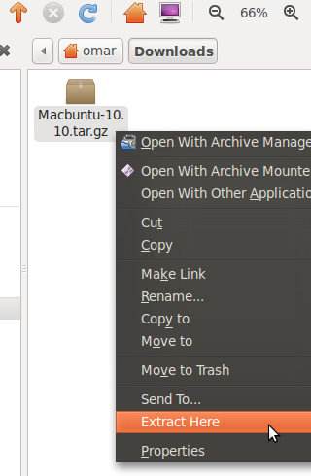](http://rtfq.net/wp-content/uploads/2011/09/Extracting-Macbuntu.png)**

To begin, download the Macbuntu package from [SourceForge](http://sourceforge.net/projects/macbuntu/files/macbuntu-10.04/v2.3/Macbuntu-10.04.tar.gz/download). Once you have the package downloaded (macbuntu.tar.gz), right click on it and press Extract Here. Note: you should be in your downloads folder.

[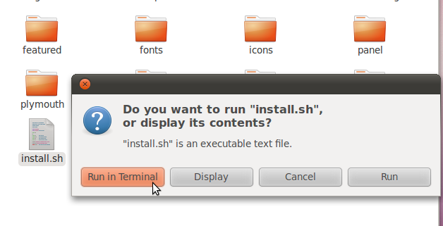](http://rtfq.net/wp-content/uploads/2011/09/Run-in-terminal.png)

When you get it extracted, open the extracted folder and find the install.sh executable text file. Double-click on this file, and choose to run in Terminal.

[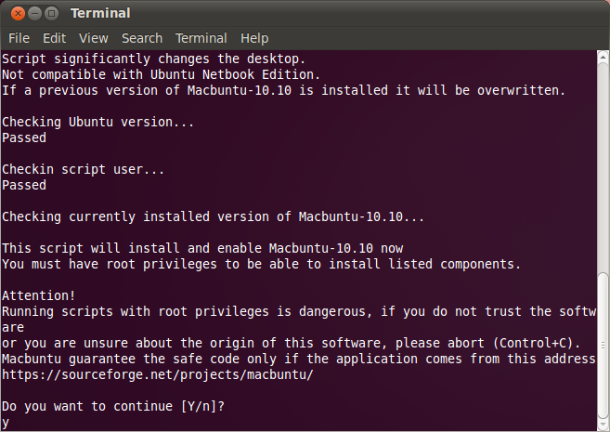](http://rtfq.net/wp-content/uploads/2011/09/Step-1-terminl.png)

A terminal window should open which looks like this.

[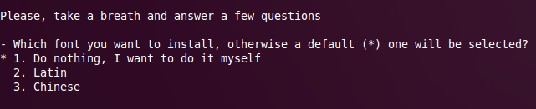](http://rtfq.net/wp-content/uploads/2011/09/Terminal-Question.png)

Type Y and hit Enter.

Here you can choose whatever you want and hit enter. If you do not want to make a choice, just hit enter. During the installation, you may be asked to download something from the Internet. If so, please select yes. Once the installation is complete, you will be asked to download the Mac themes for Firefox, Thunderbird and Chrome. If you want you can do that, just choose a location to save them. Now you will be asked to Restart

[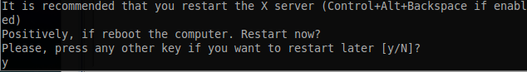](http://rtfq.net/wp-content/uploads/2011/09/Reboot.png)

After restarting you will see that your Ubuntu Desktop looks like Mac. If you don’t like the desktop background, you can always change it by   
right clicking on the desktop.

[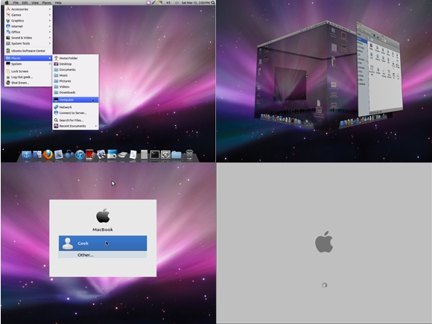](http://rtfq.net/wp-content/uploads/2011/09/Final-preview.jpg)

**Uninstalling Macbuntu**

If you don’t like Macbuntu or just don’t want it anymore, you can always revert back to the Ubuntu default style. In the folder you downloaded, there is an uninstall.sh script. Double click it and choose run in terminal. Follow the instructions and you will be back to good old Ubuntu.

Journal Post (9/28/2011)

Today we learned how to install apache 2

Using the command:

Apt-get install apache2

-cd/var >> to check the www directory

**http://local host

We also went over commands and tar.gz files:

-where is >> finds executable and source files

-find

-locate,-m locate, -s locate

**/tar/ >> directory

(joomlacode.org/gf/project/frs) webpage  
 -download tar.gz full package  
 -put in downloads folder  
 -extract to desktop  
 -use tar

>>create a tar.gz file using touch command  
 -tarball.gz –ls-lf

**Journal Post (Mon. – Oct. 6,2011)**

Today we installed SAMBA SERVER

-looked at How 2 forge website

-went over the different directories that make up the linux file system:

|  |  |
| --- | --- |
| / | *Primary hierarchy* root and [root directory](http://en.wikipedia.org/wiki/Root_directory) of the entire file system hierarchy. |
| /bin/ | Essential command [binaries](http://en.wikipedia.org/wiki/Executable) that need to be available in [single user mode](http://en.wikipedia.org/wiki/Single_user_mode) |
| [/boot/](http://en.wikipedia.org/wiki/boot/) | [Boot loader](http://en.wikipedia.org/wiki/Boot_loader) files, *e.g.*, [kernels](http://en.wikipedia.org/wiki/Kernel_(computer_science)), [initrd](http://en.wikipedia.org/wiki/Initrd); often a separate partition |
| /dev/ | Essential [devices](http://en.wikipedia.org/wiki/Device_file) |

/etc/ Host-specific system-wide [configuration files](http://en.wikipedia.org/wiki/Configuration_file)

|  |  |
| --- | --- |
| /home/ | Users' [home directories](http://en.wikipedia.org/wiki/Home_directory), containing saved files, personal settings, etc.; often a separate partition |
| /media/ | Mount points for removable media such as [CD-ROMs](http://en.wikipedia.org/wiki/CD-ROM) (appeared in FHS-2.3). |
| /mnt/ | Temporarily [mounted](http://en.wikipedia.org/wiki/Mount_(computing)) filesystems. |
| /opt/ | Optional [application software](http://en.wikipedia.org/wiki/Application_software) [packages](http://en.wikipedia.org/wiki/Software_package_(installation)).[[27]](http://en.wikipedia.org/wiki/Filesystem_Hierarchy_Standard#cite_note-26) |
| /proc/ | Virtual [filesystem](http://en.wikipedia.org/wiki/File_system) documenting [kernel](http://en.wikipedia.org/wiki/Kernel_(computers)) and [process](http://en.wikipedia.org/wiki/Process_(computing)) status as text files, e.g., uptime, network. In Linux, corresponds to a [Procfs](http://en.wikipedia.org/wiki/Procfs) mount. |
| /root/ | [Home directory](http://en.wikipedia.org/wiki/Home_directory) for the [root](http://en.wikipedia.org/wiki/Superuser) user. |
| /sbin/ | Essential system binaries, e.g., init, ip, mount. |
| /srv/ | Site-specific [data](http://en.wikipedia.org/wiki/Data) which is served by the system. |
| /tmp/ | Temporary files (see also /var/tmp). Often not preserved between system reboots. |
| /usr/ | Secondary hierarchy for read-only user data; contains the majority of ([multi-](http://en.wikipedia.org/wiki/Multi-user))user utilities and applications |
| /var/ | Variable files—files whose content is expected to continually change during normal operation of the system—such as logs, spool files, and temporary e-mail files. Sometimes a separate partition. |

**Journal Post (Wed. – Oct. 8,2011)**

Today we downloaded Virtual Box and used VDI or ISO images to load different operating systems on it. I downloaded Android OS, Mint 11 OS, and PCLinux OS. The Virtual Box application is a great tool to learn about new operating systems and try them out, it can also be used for training and testing purposes. Everything was successful really enjoyed the lab and will start experimenting with the different OS s I have installed.

**Journal Post (Wed. – Oct. 11,2011)**

Today we installed gimp.

Using the terminal command: **sudo apt-get install gimp**

Gimp is an open source graphics editor that can retouch or edit images.

The installation was successful but the program will take some time getting used to.

Pretty nice program to be free, compares nicely to photo shop without the incurred cost.

**Journal Post (Wed. – Oct. 17,2011)**

Today we went over the permissions command using “chmod, chgrp, chown

Also review for out test on Wed.

Permissions  
*u* - User who owns the file.  
*g* - Group that owns the file.  
*o* - Other.  
*a* - All.  
*r* - Read the file.  
*w* - Write or edit the file.  
*x* - Execute or run the file as a program.

400 read by owner  
040 read by group  
004 read by anybody (other)  
200 write by owner  
020 write by group  
002 write by anybody  
100 execute by owner  
010 execute by group  
001 execute by anybody

-rw-rw-r-- 1 hope 123 Feb 03 15:36 file.txt

|  |  |  |  |  |  |  |  |  |
| --- | --- | --- | --- | --- | --- | --- | --- | --- |
| - | rw | rw- | r-- | 1 | hope | 123 | Feb 03 15:36 | file.txt |
| File | owner | group | everyone else | links | owner | size | mod date | file name |

Things to know:

-panel

-button (add)

-terminal (alt-shift-f2) (applications/accessories)

-ifconfig

-sudo if up eth# >> the # = the Ethernet port you want to choose

-/etc/int.d/networking start or /etc/int.d/networking force-reload

=gksudo gedit /etc/hosts

* Gksudo gives you permission to manipulate a file
* Sudo does the same

-sudo passwd root >> to set a root password

-shutdown –h 3:00 >>> shuts down the system at hour 3:00 military time

-to resolve DNS >>> vim/etc/resolv.conf

**Journal Post (Wed. – Oct. 19,2011)**

Today went took our written test.

Also in the test we installed a cool program called Stellarium which is an open source planetarium for your computer.

Using the terminal command:

sudo add-apt-repository

ppa:stellarium/stellarium-releases

sudo apt-get update

**Journal Post (Mon. – Oct. 24,2011)**

Today we installed the new Ubuntu 11.10.

I installed the new operating system to my 500 GB portable USB drive and made the whole drive with persistence.

A successful lab, really enjoy the new OS. Lots of new features with an application dock

To Do List After installing Ubuntu 11.10

[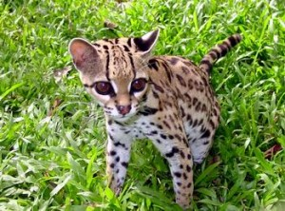](http://rtfq.net/?attachment_id=347)Oneiric Ocelot, that’s the new [Ubuntu](http://www.ubuntu.com/) version we would be using for the next 6 months. It has, as always, improved and it’s better than its predecessors. It has a lot more UI work and it will please those coming from [Mac OS](http://www.apple.com/macosx/). The Ubuntu font is getting better and I really like it and using it as my default everywhere on my system. It’s more and more “search and enter/click” than “click, click, click…”. With the latest developments in how we actually use things these days, it’s the right path. In a few years, the way we currently view our file structure would become old school. In Oneiric Ocelot, this idea has been pushed to all parts where all applications that have about the same purpose are put together for easy access. So let’s check what’s new in a fresh installation.

**Top menu bar**

the settings menu now include display settings, startup applications, attached devices, systems settings and the usual shutdown menu items. Those menu items are the ones we usually need when trying to customize the OS, so it makes sense to give easy access to them.  
the system settings menu item brings you a dialog where all settings icons are in one place, again nice easy access to everything about settings.

**Software Center**

The software center basically the Ubuntu app store has got even better. Better categorisation rating, what’s new… It now has the ability, through Oneconf, to sync installed applications between computers which is awesome. You can now have the same set of applications on all your desktop/notebook setups.

Now the followings could be done by using the [Ubuntu Software Center](https://wiki.ubuntu.com/SoftwareCenter), but if you’re like me and like to see what’s behind all the magic “click click click”, follow along.

First let’s get backed up by more repositories, bring up the dashboard and type “terminal” which shows you the terminal icon for u to launch it. Then manually edit your sources list with:

sudo gedit /etc/apt/sources.list

you can replace its contents with [mine](http://rtfq.net/?cat=50) :)

Get your system up to date with :

sudo apt-get update && sudo apt-get dist-upgrade

Now that all your current programs are on their latest version, let’s install some useful stuff:

– [Anti-Virus](http://www.symantec.com/en/uk/business/theme.jsp?themeid=protection-suite)

Ubuntu is getting popular so it might be getting some nasty shit along. so be a little carefull with some antivirus :

Windows equivalent : [AVG AntiVirus](http://www.avg.com/), NAV, TrendMicro, F-Prot, Kaspersky, …

Ubuntu equivalent : [ClamAV](http://www.clamav.net/), Avast

ClamAV

sudo apt-get install clamav clamtk

Avast

wget http://files.avast.com/files/linux/avast4workstation_1.3.0-2_i386.deb && sudo dpkg -i avast4workstation_1.3.0-2_i386.deb

– Essential tools for compiling from sources

some applications aren’t available in repositories. so you’ll have to compile them from sources. for that you’ll need to install some tools:

sudo apt-get install build-essential checkinstall cdbs devscripts dh-make [fakeroot](http://en.wikipedia.org/wiki/Superuser)libxml-parser-perl check avahi-daemon

– [Java runtime environment](http://en.wikipedia.org/wiki/Java_Virtual_Machine)

Java is a very important thing to install, now that many programs like Netbeans need it to run. First add the launchpad repository So type:

sudo apt-get install sun-java6-jre sun-java6-plugin sun-java6-fonts

– Multimedia

Windows equivalent : windows media player, real player, vlc, mplayer

Ubuntu equivalent : vlc, mplayer, helix player

To have Ubuntu playing all kinds of stuff, you need to install many codecs. So on the Terminal, type:

* [Installing](http://en.wikipedia.org/wiki/Installation_%28computer_programs%29) vlc and mplayer (plays almost everything):

sudo apt-get install vlc mplayer

* Common packs

sudo apt-get install libxine1-ffmpeg gxine mencoder mpeg2dec vorbis-tools id3v2 mpg321 mpg123 libflac++6 ffmpeg libmp4v2-0 totem-mozilla icedax tagtool easytag id3tool lame nautilus-script-audio-convert libmad0 libjpeg-progs libquicktime1 flac faac faad sox ffmpeg2theora libmpeg2-4 uudeview flac libmpeg3-1 mpeg3-utils mpegdemux [liba52](http://www.mplayerhq.hu/)-0.7.4-dev gstreamer0.10-ffmpeg gstreamer0.10-fluendo-mp3 gstreamer0.10-gnonlin gstreamer0.10-sdl gstreamer0.10-plugins-bad-multiverse gstreamer0.10-schroedinger gstreamer0.10-plugins-ugly totem-gstreamer gstreamer-dbus-media-service gstreamer-tools ubuntu-restricted-extras

* Enable dvd support

sudo apt-get install libdvdread4 && sudo /usr/share/doc/libdvdread4/./install-css.sh

* Flash

sudo apt-get install gsfonts gsfonts-x11 flashplugin-installer

– Missing Windows software?? Run Windows softwares in Linux!!!

Run [Windows Applications](http://www.microsoft.com/WINDOWS) such as 7zip, Google Sketchup, [AutoCAD](http://www.autodesk.com/autocad), Dreamwaver, Flash MX, Fireworks MX, IE6, IE7, Safari, Itunes, [Windows Media Player](http://en.wikipedia.org/wiki/Windows_Media_Player) and many more…

Play Windows Games in Linux like Age Of Empires, Call Of Duty, Diablo, Fear, Fallout, Far Cry, Grand Theft Auto, Half Life, Halo, Hitman, Max Payne, Need For Speed, Prince Of Persia, Sim City Star Wars, The Simsworld of warcraft , Tomb Raider, Warcraft, World Of Warcraft, Counterstrike and many other can be played.

Install [Playonlinux](http://www.winehq.org/). It’s based on wine. Wine is a compatibility layer for running Windows programs in Linux.

Add the launchpad repositories

sudo add-apt-repository ppa:ubuntu-wine/ppa && sudo apt-get update

sudo apt-get install wine playonlinux

– Archiver/ Packing software

Windows equivalent : winrar, zip, 7zip

Ubuntu equivalent : tar, unrar, p7zip, arj, unace

It’s bad when you don’t have Internet on your computer/notebook, but you have to pack/unpack something but the file format isn’t recognized by the system. To prevent from this bad situation, you can install a bunch of packing software by typing this on the terminal:

sudo apt-get install unace rar unrar zip unzip p7zip-full p7zip-rar sharutils uudeview mpack lha arj cabextract file-roller

– Graphical web browser

Windows equivalent : Internet explorer, firefox

Ubuntu equivalent : Firefox, chromium

Firefox (installed by default oneiric)

sudo apt-get install firefox

Chromium (open source equivalent of Google Chrome)

sudo apt-get install chromium-browser chromium-browser-l10n chromium-codecs-ffmpeg

– Download Manager

Windows equivalent : Free download manager

Ubuntu equivalent : Multiget

MultiGet is a http/ftp downloader with a nice GUI for Linux desktop users. It can run on almost all desktops without any configuration. It has many powerful functions comparing to others.

sudo apt-get install multiget

– Graphical Email client

Windows equivalent : Outlook

Ubuntu equivalent : Evolution, Thunderbird

Evolution

sudo apt-get install evolution evolution-mapi

Thunderbird

sudo apt-get install thunderbird

– Instant Messanging protocal clients

Windows equivalent : MSN messenger, Yahoo messenger, QQ, AIM, Gtalk, ICQ,IRC

Ubuntu equivalent : Empathy, Pidgin, emesene

Empathy IM Client (installed by default)

Add the related launchpad repository :  
sudo add-apt-repository ppa:telepathy/ppa && sudo apt-get update

Then install it by running the following :  
sudo apt-get install empathy telepathy-mission-control-5 telepathy-gabble telepathy-butterfly telepathy-haze telepathy-idle telepathy-salut telepathy-sofiasip libtelepathy-farsight0 python-tpfarsight galago-eds-feed python-galago python-galago-gtk msn-pecan

Pidgin

Pidgin is an easy to use and free chat client used by millions. Connect to AIM, MSN, Yahoo, and more chat networks all at once. Supported chat networks: AIM, Bonjour, Gadu-Gadu, Google Talk, Groupwise, ICQ, IRC, MSN, MySpaceIM, QQ, SILC, SIMPLE, Sametime, XMPP, Yahoo!, Zephyr

sudo apt-get install pidgin pidgin-data pidgin-lastfm pidgin-guifications msn-pecan pidgin-musictracker pidgin-plugin-pack pidgin-themes

Emesene only for MSN Messenger.

sudo apt-get install emesene

– VOIP

Windows equivalent : skype

Ubuntu equivalent : skype

Skype

sudo apt-get install skype

– Viewing PDF files

Windows equivalent : Adobe Reader

Ubuntu equivalent : Adobe Reader

Adobe Reader

sudo apt-get install acroread

– Adobe Air

wget http://airdownload.adobe.com/air/lin/download/latest/AdobeAIRInstaller.bin  
chmod +x ./AdobeAIRInstaller.bin

sudo ./AdobeAIRInstaller.bin

– Music / MP3 / OGG Players

Windows equivalent : iTunes, Winamp

Ubuntu equivalent : Rhythmbox, Banshee, Amarok

Rhythmbox

sudo apt-get install rhythmbox

Banshee

sudo apt-get install banshee banshee-extension-ubuntuonemusicstore banshee-extension-appindicator banshee-extension-lyrics banshee-extension-mirage

Amarok

sudo apt-get install amarok amarok-common

– Vector Graphics Editor

Windows equivalent : Adobe Illustrator

Ubuntu equivalent : Inkscape

Inkscape

sudo apt-get install inkscape

– Image Editor

Windows equivalent : Adobe Photoshop, Paint.Net

Ubuntu equivalent : GIMP

GIMP

sudo apt-get install gimp gimp-data gimp-plugin-registry gimp-data-extras

**Pinta**

sudo apt-get install pinta

– 3D Graphics Applications

Windows equivalent : 3D Studio MAX

Ubuntu equivalent : Blender

Blender

sudo apt-get install blender

– Simple Yet Advanced Text Editor

Windows equivalent : Notepad ++

Ubuntu equivalent : GEdit

GEdit

sudo apt-get install gedit gedit-plugins gedit-developer-plugins

– Office Applications

Windows equivalent : Microsoft Office

Ubuntu equivalent : LibreOffice

LibreOffice

Add the launchpad repository :  
sudo add-apt-repository ppa:libreoffice/ppa && sudo apt-get update

sudo apt-get install libreoffice libreoffice-pdfimport libreoffice-math libreoffice-wiki-publisher libreoffice-report-builder libreoffice-gnome

– Microsoft Visio

Windows equivalent : Microsoft Visio

Ubuntu equivalent : Dia

Dia

sudo apt-get install dia

– Microsoft Project

Windows equivalent : Microsoft Project

Ubuntu equivalent : OpenProj

OpenProj

wget http://nchc.dl.sourceforge.net/sourceforge/openproj/openproj_1.4-2.deb && sudo dpkg -i openproj_1.4-2.deb

– Development IDE

Windows equivalent : Dreamweaver

Ubuntu equivalent : Quanta, Kompozer, NetBeans

Quanta

sudo apt-get install quanta

Komposer

sudo apt-get install kompozer

NetBeans

sudo apt-get install netbeans

- Source Control Management

Windows equivalent : TortoiseSVN

Ubuntu equivalent : RabbitVCS

RabbitVCS

Then install it :  
sudo apt-get install rabbitvcs-cli rabbitvcs-gedit rabbitvcs-nautilus  
killall nautilus

Right Click on any folder or file and access the RabbitVCS submenu

– Graphical FTP clients

Windows equivalent : CuteFTP, SmartFTP

Ubuntu equivalent : FileZilla

FileZilla

This is great FTP program, very complete, in my opinion, the best one for linux.

On the terminal type:

sudo apt-get install filezilla filezilla-common

– P2P Clients / Servers, File Sharing

Windows equivalent : utorrent, azureus, emule

Ubuntu equivalent : Deluge, azureus, amule

Bittorent clients

Deluge

Then install it :  
sudo apt-get install deluge-torrent

Azureus: Uses Java to run, very complete but a bit heavy

sudo apt-get install azureus

Emule Donkey Clients

Amule

sudo apt-get install amule

– Programs for CD burning with GUI

Windows equivalent : Nero, Roxio Easy CD Creator

Ubuntu equivalent : K3b, Brasero

K3b

Nero is available for Linux,but it’s not free.A trial is available for 1 month usage and later it asks or activation code.But K3B is as good as Nero.Have a good feature set as Nero.

sudo apt-get install k3b k3b-data libk3b6

Brasero

sudo apt-get install brasero

– Photo Management

Google Picasa

Google Picasa is a professional good-looking photo management application available on Windows ,Linux and Mac OS. Now Google Picasa has a number of features that many photo management software on Linux don’t have further Google Picasa looks very user-friendly as compared to similar open source application available on Linux . Now Google Picasa for Linux is not a native Linux application but runs on Linux thru application layer called wine which allows many windows application to run flawlessly on Linux.

Now to install Google – Picasa type the following command in the terminal window

wget http://dl.google.com/linux/deb/pool/non-free/p/picasa/picasa_3.0-current_i386.deb && sudo dpkg -i picasa_3.0-current_i386.deb

if you’re using 64 bit OS, replace “picasa_3.0-current_i386.deb” with “picasa_3.0-current_amd64.deb”

– Map Viewing and Management

Google Earth

To install Google Earth type the following command in the Terminal Window.

sudo apt-get install googleearth-package

After downloading is over you will get a screen like this press ¨Yes¨ to accept the license agreement and complete software installation.

– Configure Firewall  
If you are concerned about your security, then it is pertinent that you activate the firewall and prevent any unauthorized access to your computer.

UFW is installed by default, but if you need a graphical interface, install GUFW.

sudo apt-get install gufw

**– Ubuntu Tweak**

Ubuntu Tweak allows you to tweak your system settings, all in one place. You can install new applications, customize your desktop settings, configure your startup applications, changing the system file type association and many more tweaks in this single application.

Add the launchpad repository :  
sudo add-apt-repository ppa:ubuntu-tweak-testing/ppa && sudo apt-get update

Then install it with the following command :  
sudo apt-get install ubuntu-tweak

**App Runner**

App Runner is a small open source utility that makes it very easy to run any type of program/executable/script on any distro/OS that uses the nautilus file manager: Debian/Ubuntu/Super OS/Fedora/etc

wget http://hacktolive.org/files/downloads/app-runner/app-runner-0.5.2.deb && sudo dpkg -i app-runner-0.5.2.deb

**Things to do after Ubuntu 11.10 Install (Corrections)**

## 1- Didn`t like Unity? Switch to ubuntu Gnome classic

(COMMANDS WORKED)

 sudo apt-get update

sudo apt-get install unity-2d

## 2- Install Updates:

(COMMANDS WORKED)

sudo apt-get update && sudo apt-get upgrade

## 3- Ubuntu-Tweak (EDITED – COMMANDS)

sudo add-apt-repository ppa:tualatrix/next  
sudo apt-get update  
sudo apt-get install ubuntu-tweak

## 4- Add Medibuntu repositories and activate Canonical partner repositories

(NEVER COULD INSTALL)

## 5- Sharing folders in  Oneiric Ocelot

(COMMANDS WORKED)

sudo apt-get install samba

## 6-Install Media Utilities

(COMMANDS WORKED)

sudo apt-get install vlc

sudo apt-get install non-free-codecs libxine1-ffmpeg gxine mencoder libmpcdec3 libquicktime1 flac faac faad sox ffmpeg2theora libmpeg2-4 uudeview flac libmpeg3-1 mpeg3-utils mpegdemux liba52-dev mpeg2dec vorbis-tools id3v2 mpg321 mpg123 libflac++6 ffmpeg libmp4v2-0

totem-mozilla icedax tagtool easytag id3tool lame nautilus-script-audio-convert libmad0 libjpeg-progs

sudo apt-get install libdvdcss2 && sudo /usr/share/doc/libdvdread4/./install-css.sh

sudo add-apt-repository ppa:sevenmachines/flash

sudo apt-get update

sudo apt-get install flashplugin64-installer

## 7. Want to install windows games and applications?(COMMANDS WORKED)

sudo apt-get install playonlinux

## 8- Ubuntu Gaming made easy with PlayDeb (COMMANDS WORKED)

deb http://archive.getdeb.net/ubuntu jaunty-getdeb games (Add to source.list)

wget -O- http://archive.getdeb.net/getdeb-archive.key | sudo apt-key add -

9- Media centers:  XMBC (EDITED COMMANDS)

<https://skydrive.live.com/redir.aspx?cid=fc457c24739d39f9&resid=FC457C24739D39F9%21108> (down load file and save as executable)

Run command (./Downloads/medibuntu-restricted-extras-xbmc-installer.sh )

## 10- Video editors: Openshot (COMMANDS WORKED)

sudo add-apt-repository ppa:jonoomph/openshot-edge

sudo apt-get update

sudo apt-get install openshot openshot-doc

## 12- Bitorrent client (COMMANDS WORKED)

sudo add-apt-repository ppa:deluge-team/ppa

sudo apt-get update

sudo apt-get install deluge

sudo apt-get install vuze

## 13- Filezilla the best ftp client for linux (COMMANDS WORKED)

sudo apt-get install filezilla

## 14- Communication : Instant messengers (EDITED COMMANDS)

sudo apt-get install pidgin

sudo apt-get install amsn

Skype: Activate Canonical Partners in Software Center then download Skype with the given download tab

15. Installing the latest Java run time JRE  
(COMMANDS WORKED)

sudo add-apt-repository ppa:ferramroberto/java

sudo apt-get update

sudo apt-get install sun-java6-jre sun-java6-plugin sun-java6-fonts

## 16- DropBox (COMMANDS WORKED)

<http://www.dropbox.com/download?dl=packages/nautilus-dropbox_0.6.7_amd64.deb> (download link)

## 17- VirtualBox (EDITED COMMANDS)

sudo add-apt-repository "deb http://download.virtualbox.org/virtualbox/debian oneiric contrib"

wget -q http://download.virtualbox.org/virtualbox/debian/oracle_vbox.asc -O- | sudo apt-key add -

sudo apt-get update

sudo apt-get install virtualbox-4.1

## 18. Image editor (COMMANDS WORKED)

sudo add-apt-repository ppa:matthaeus123/mrw-gimp-svn

sudo apt-get update

sudo apt-get install gimp gimp-data gimp-plugin-registry gimp-data-extras

## 19. Installing some eye candy (COMMANDS WORKED)

sudo apt-get install conky

sudo apt-add-repository ppa:screenlets/ppa

sudo apt-get update

sudo apt-get install screenlets

## 20. Installing Archive Management Apps (COMMANDS WORKED)

sudo apt-get install unace unrar zip unzip p7zip-full p7zip-rar sharutils rar uudeview mpack lha arj cabextract file-roller

## 21. Y PPA Manager (COMMANDS WORKED)

sudo add-apt-repository ppa:webupd8team/y-ppa-manager

sudo apt-get update

sudo apt-get install y-ppa-manager

**Journal Post (Nov. 2, 2011)**

Today we installed inkscape.

Inkscape is a vector graphics editor that is open source and compares to adobe illustrator.

We installed inkscape using the terminal command:

**sudo apt-get install inkscape**

**The installation was successful and play with the editor was a blast.**

**You can make all sorts of images and designs with this incredible tool.**

Inkscape graphics assignment



**Journal Post (Nov. 7, 2011)**

Today we installed Linux Mint 11 using Virtual Box.

Linux Mint is one of the most popular forms of Linux due to its layout which mimics Windows OS.

We played around with this new operating system and made comparisons to it and Ubuntu. Personally I like the Mint operating system and look forward to using it a lot more in the future.

**Linux Mint Project**

**Pin Programs to the Panel**

Frequently used programs can be easily pinned to the panel.

1. Browse to a program from Menu > Applications.
2. Drag and drop the program to an empty space in the panel, or right-click the program and select “Add to panel”.
3. Right click the program icon, select “Move” and drop it to a new place in the panel.
4. Right click the program icon and select “Lock to Panel”.

**Set Fully Transparent Panel**

When you set the panel to be transparent in the default Mint-X-Metal theme, you will find that some panel items’ backgrounds are not transparent, but you can opt for one of the other themes, such as AuroraMint theme, which comes with the transparent background for the panel items. If you prefer the default theme with the items’ backgrounds transparent, some tweaks are needed with the steps below:

1. Click Menu and select Terminal.
2. Enter cp -R /usr/share/themes/Mint-X-Metal ~/.themes/
3. Enter gedit ~/.themes/Mint-X-Metal/gtk-2.0/panel.rc to open the file with gedit.
4. Search for three instances of “Panel/panelbg.png”
5. Comment out all three lines by placing a # at the beginning of the lines, for example: # bg_pixmap[NORMAL] = …, or # file = …
6. Save the file.
7. Go to Menu > Applications > Preferences > Appearance, switch to the other theme and then back to the Mint-X-Metal theme.

Note: If you’d like to change to the Mint-X theme, replace Mint-X-Metal with Mint-X in the above command lines.

**Set Preferences for the Start Menu**

Like the Windows’ Start button, Linux Mint has an advanced Gnome menu called “mintMenu” where you can start doing things like running a program, looking for files, log out or quit the system and so on.

This menu allows you to set your personal preferences with the steps below, for example:

1. Right click “Menu”, select “Preferences”.
2. In the “Main button” tab, remove the word “Menu” from the “Button text” box if you like to hide the text.
3. Change the keyboard shortcut from <Control>Super_L to others, such as Super_R, if you’d like to just press the right Windows key to get to the menu. (This change only takes effect after logging out and back in the system.)
4. Change the Button icon from /usr/lib/linuxmint/mintMenu/visualisation-logo.png to /usr/lib/linuxmint/mintMenu/mintMenu.png, as shown in the screenshot. (Caution: avoid changing to a huge size image which might affect the panel.)
5. In the Places tab, untick the items in “Toggle Default Places” to hide from the Menu.
6. In the System tab, untick the items in “Toggle Default Items” to hide from the Menu.

Other preferences can also be set in the Options, Theme, Applications and Favorites tabs.

**Enable Superbar**

In Windows 7, frequently used programs can be pinned to the taskbar (hence called Superbar). Likewise, DockBarX, a Gnome panel plugin, can be added to Linux Mint to achieve almost the same effect to pin and unpin or launch the applications from the panel.

1. Go to Menu > Software Manager > Edit > Software Source.
2. Select “Other Software” and click “Add”
3. At APT line, enter ppa:dockbar-main/ppa, click “Add Source” “Refresh” and “Close”
4. In the Software Manager window, enter dockbarx inside the Search box to look for dockbarx, which is available after the above steps.
5. Select Dockbarx and click “Install”
6. Log out and back into the system, then right click the panel and click “Add to Panel”.
7. Select the DockBarX Applet and click “Add”.

Note: A thumbnail preview of a running program is also available to DockBarX. To enable this feature, right-click the DockBarX item on the panel, select Properties, choose Window List and tick “Show Previews”. Other preferences such as appearance, window item and group button can also be configured by users.

**Change Font Type and Color of Panel Clock**

The font type and color of the panel clock follow the windows text in a theme by default. In particular, if the font color is black and shown on a dark background through a transparent panel, you can’t read the clock clearly, but you can tweak it by changing the font color. And you can define the font type for your panel clock as well.

The code in Step 1 below sets the font color to white and applies Digital Face font (Note 1), bold and size 16.

1. Open up the text editor Gedit and paste the following code:  
   style “my-panel-clock”  
   {  
   fg[NORMAL] = “#FFFFFF”  
   font_name = “digital-7 bold 16″  
   }  
   widget “*.clock-applet-button.*” style “my-panel-clock”
2. Save the file as .gtkrc-2.0 (including the dot in front of the filename) inside your home directory /home/your_user_name.
3. Log out and log back in (OR enter killall gnome-panel into the Terminal) to see the change.

Note 1: The Digital Face font can be downloaded [here](http://scribusstuff.org/content/show.php/Digital+Face+Font?content=106020). After downloading, unzip the file, enter sudo mv digital-7.ttf /usr/share/fonts/truetype into Terminal to move the font file to the restricted folder. See also [Install Extra Fonts](http://www.techsupportalert.com/content/tips-and-tricks-linux-mint-after-installation.htm#Install-Extra-Fonts).

Note 2: The filename leading by a dot represents it’s a hidden file and visible by toggling the key Ctrl-H in the Nautilus file browser.

**Open Up a Window in Center**

When running an application without maximized, Linux Mint always puts it in the left-top corner of the desktop by default, but you are allowed to set a program window to open up in the center of the desktop area.

1. Press Alt+F2 to bring up “Run Application” window.
2. Type ccsm into the box and click Run to bring up CompizConfig Settings Manager.
3. Select “Windows Management” from the left panel.
4. Click “Place Windows”.
5. Change Placement Mode from “Smart” to “Centered”, click “Back” and “Close”.

Ideally, the window manager in Linux Mint should restore the last known position of an application window, but it does not do that unless an application remembers its own window position.

**Roll Up and Down a Window**

When you double-click the title bar of a window, the default setting is to maximize a window. Since there’s already a maximize button you can use for this, I always like to change the default setting to rolling up (or ‘shading’) a window when I double-click on its title bar.

1. Go to Menu > Control Center > Personal
2. Click “Windows” to open up “Window Preferences”.
3. In “Titlebar Action”, select “Roll up” (or “Shade”) from the drop-down list.

Now you can roll up a window when you double-click its title bar, and roll it down by double-clicking the title bar again. Simple as that.

**Customize the Theme**

Linux Mint is using the Mint-X-Metal as the default theme, but you can either select one of the other available themes or customize it to suit your preferences easily.

1. Go to Menu > Applications > Perferences > Appearance
2. Select the other theme, for instance AuroraMint, and your window will reflect the changes to the new theme.
3. Click the “Customize” button.
4. Select one of the tabs, such as Icons.
5. Choose one of the icon packages, for example, Elementary Mint, and click the “Close” button.
6. Now it becomes your Custom theme and you can save it as a new theme, such as “AuroraMint with Elementary Icons”.

**Set Aero Glass Effect**

In Linux Mint you can set nearly the same aero glass effect to window borders with alpha transparency as available in Windows 7.

1. Press Alt+F2 to bring up “Run Application” window.
2. Type gconf-editor into the box, click “Run” to bring up Configuration Editor.
3. Browse to apps > gwd, look for “metacity_theme_active_opacity” on the right panel.
4. Change the value in “metacity_theme_active_opacity” from 1 to 0.75 (or smaller such as 0.5 for more transparency).
5. Then go to Menu > Applications > Preferences > CompizConfig Settings Manager.
6. Select “Effects” from the left panel.
7. Tick “Blur Windows” and click the “Close” button. (Note: default values in Blur Windows can be applied.)

Note: If the aero glass effect doesn’t work, check if you have updated your display driver. Go to Menu > Applications > Administration > Additional Drivers, activate the recommended graphics driver and restart the system.

Linux Mint 11 Assignment

**Pin Programs To Panel**

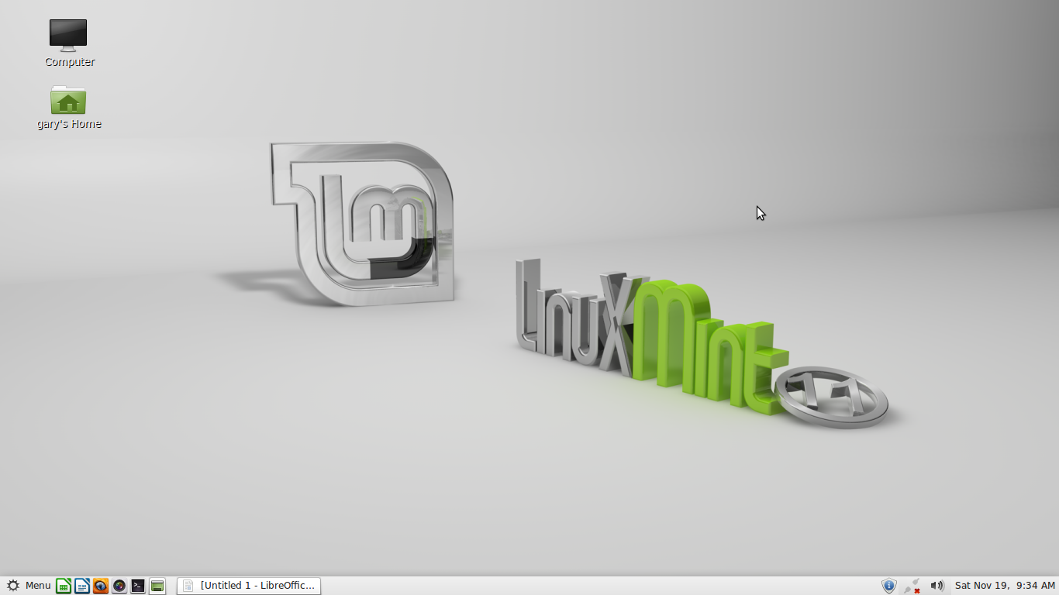

**Set Fully Transparent Panel Set Fully Transparent Panel**

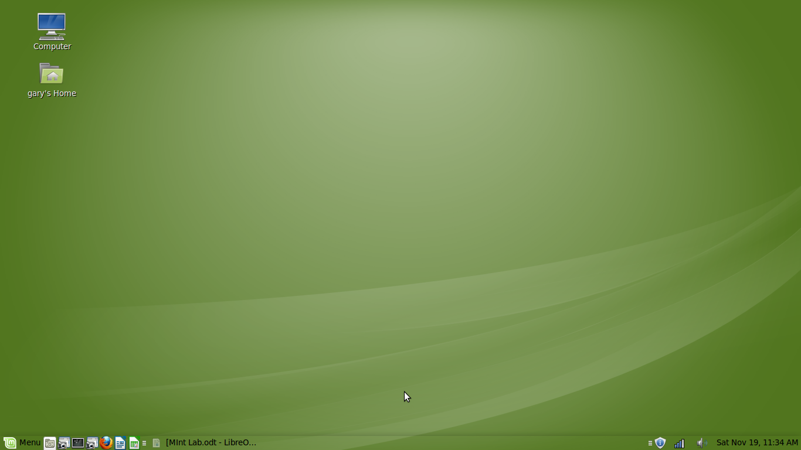

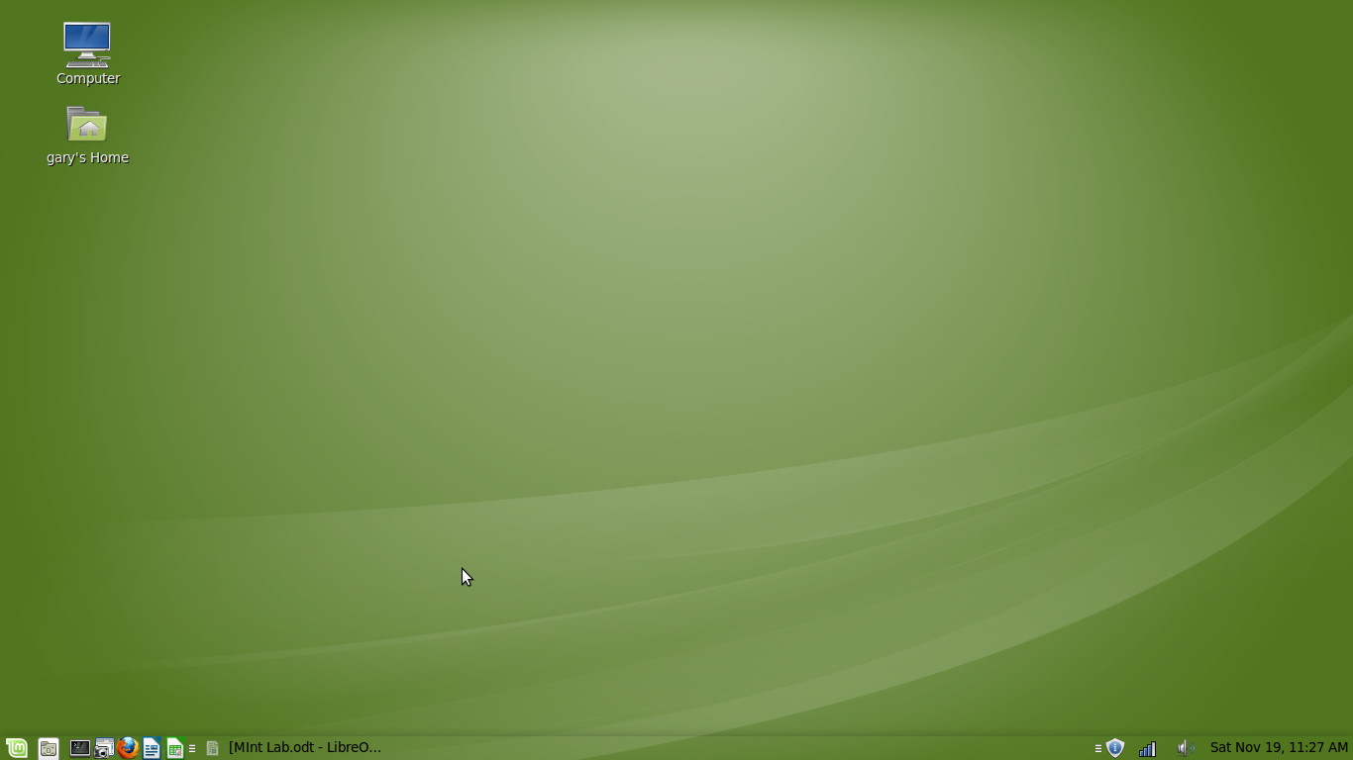**Set Preferences For The Start Menu**

**Enable Superbar**

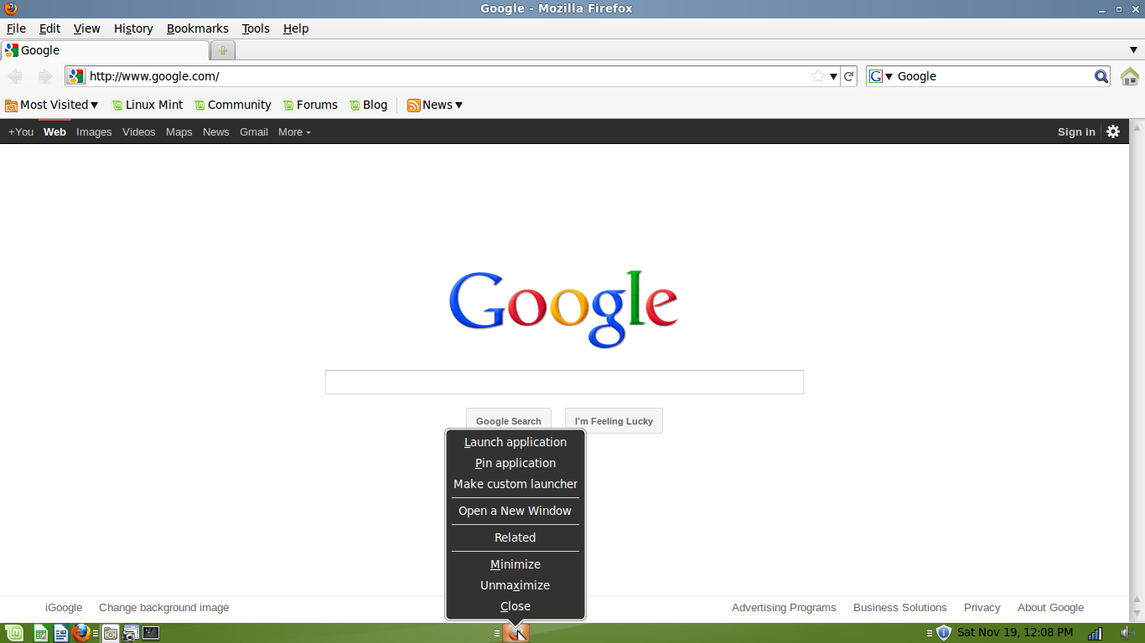

**Change Font Type And Color Of Panel Clock**

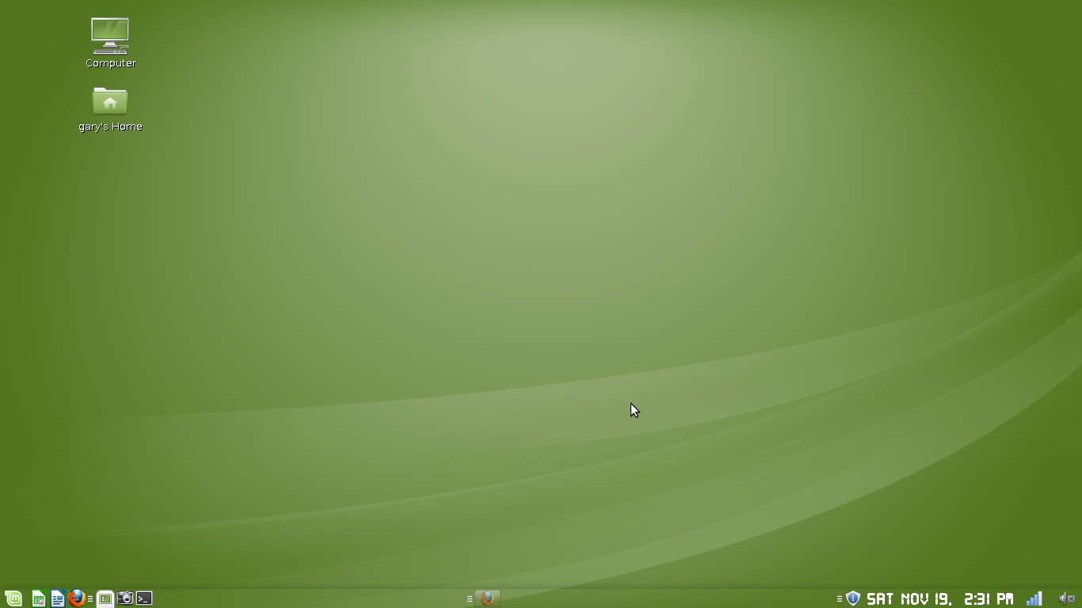

**Open Up A Window In Center**

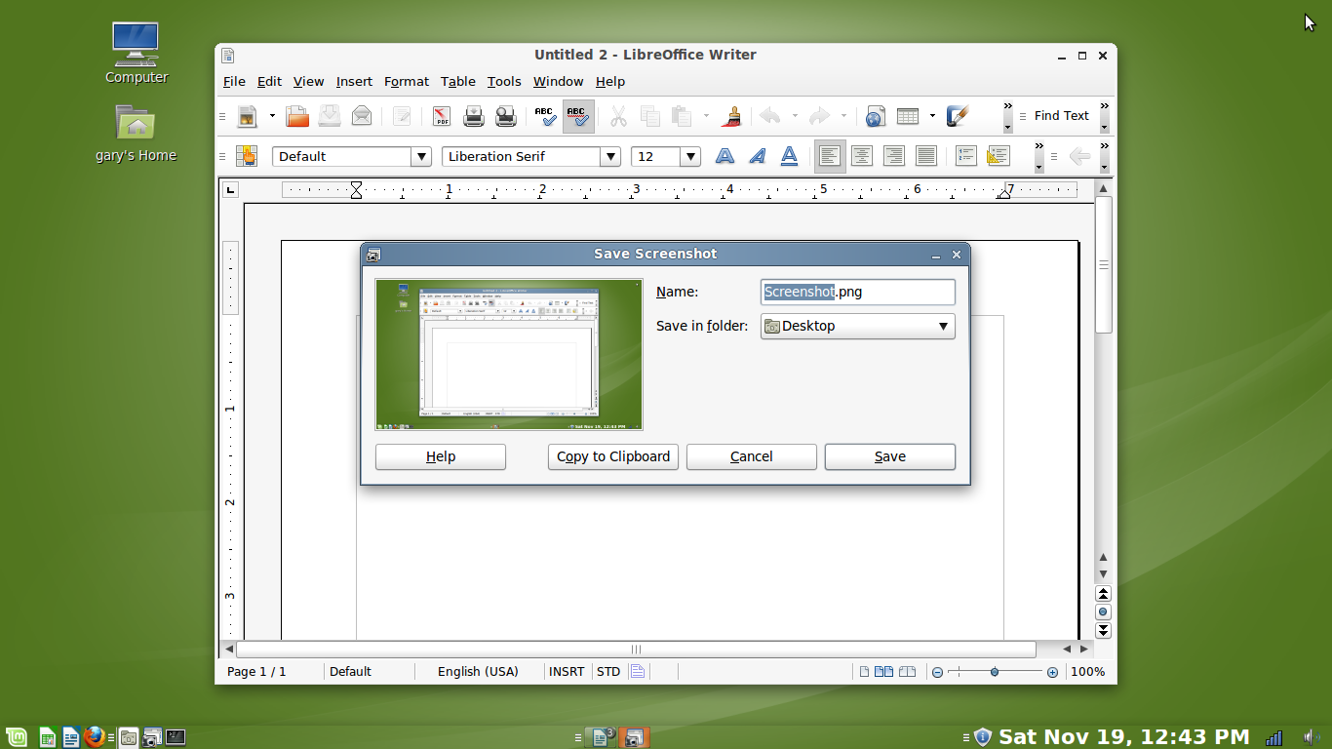

**Roll Up And Down A Window**

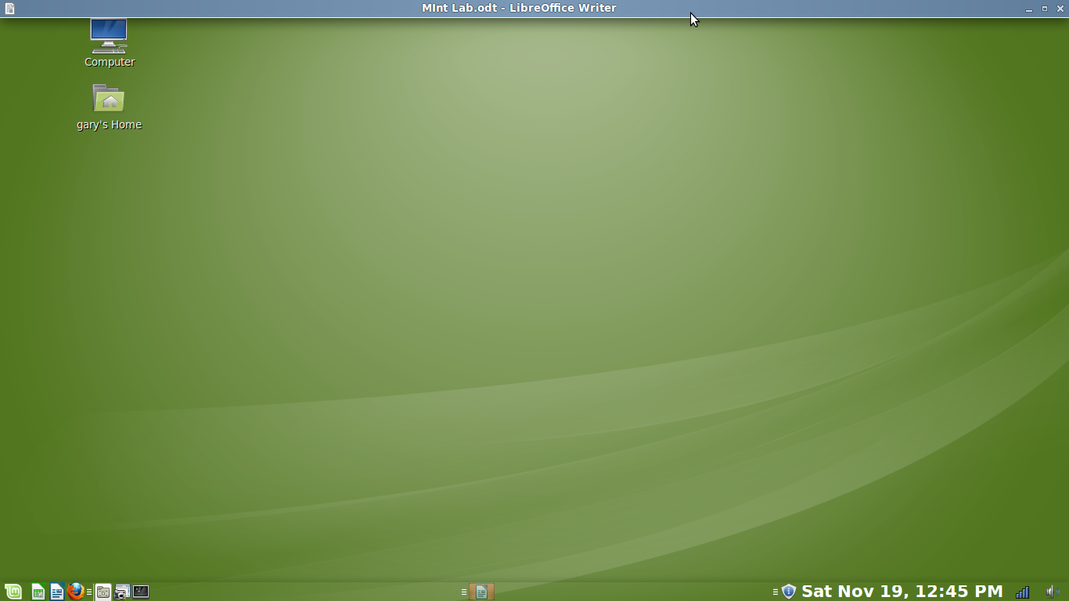

**Customize The Theme**

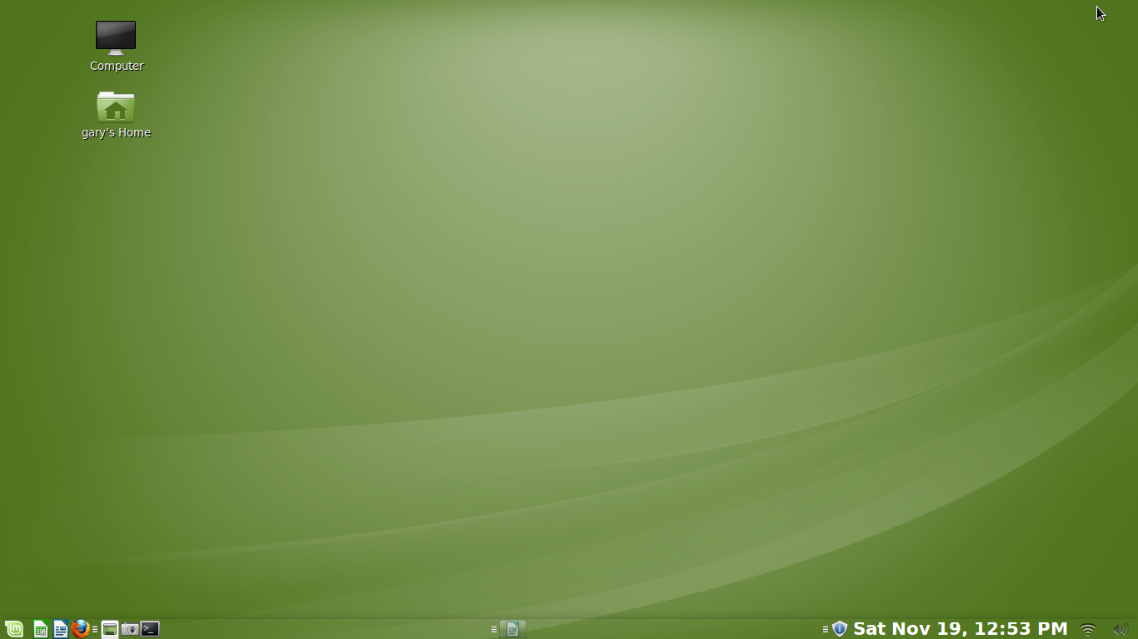

**Set Aero Glass Effect**

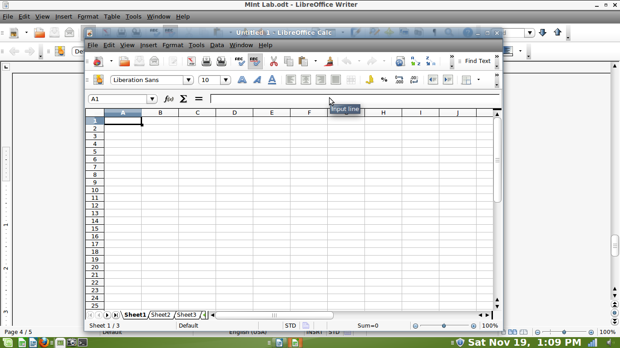

Changing Desktop Appearance On Linux Mint 11 (Advanced)

### 1 Preliminary Note

This tutorial will describe how to alter the appearance of a Linux Mint 11 system with a GNOME desktop. This is the standard desktop that comes with Mint, so if you have not changed anything about that all steps should work fine for you. Be aware that the use of the nVidia proprietary drivers may not be unrisky!

This tutorial comes without warranty of any kind!

### 2 Things I Am Going To Change About The Desktop

If you have not changed anything about your Mint desktop yet, that is approximately what it should look like

[[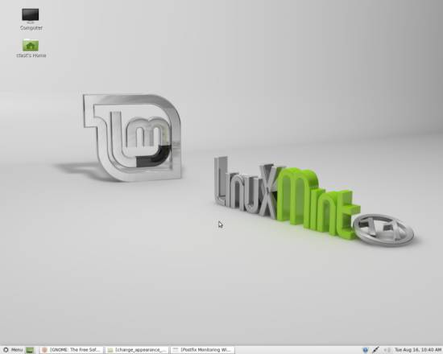](http://static.howtoforge.com/images/change_appearance_mint_advanced/big/0.jpg)](http://static.howtoforge.com/images/change_appearance_mint_advanced/big/0.jpg)

After I had gone through the options I am going to configure, my desktop looked like this:

[[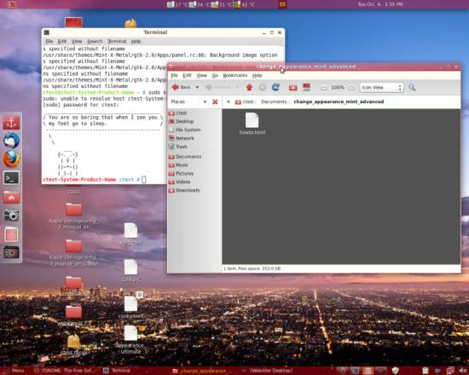](http://static.howtoforge.com/images/change_appearance_mint_advanced/big/appearance.jpg)](http://static.howtoforge.com/images/change_appearance_mint_advanced/big/appearance.jpg)

Now what I have done expilicitly is:

* Install nVidia proprietary driver - allows desktop effects
* Install Compiz Fusion - software to use desktop effects
* Install Webilder Applet - applet to download and switch wallpaper automatically
* Install Gnome Color Chooser - GUI for easily changing the desktop's colors
* Install Docky - Apple-like dock to quickstart files and folders
* Install Screenlets - Software to put helpful little widgets on your desktop
* Make the panel's opacity option affect the complete panel
* Lower the window decorations' opacity

Of course you can choose which of those options you would like to apply to your desktop, however Compiz Fusion, Docky and lowering the window decorations' opacity need the nVidia proprietary drivers to be installed.

### 3 NVIDIA Drivers and Compiz Fusion

At this point I want to note that you should only try to install the nVidia proprietary drivers after you have backed up your system and no data would be lost if you had to reinstall Linux Mint. It may easily occur that the nVidia drivers are installed incorrectly, especially if you had other drivers installed manually in the past. Also, make sure that you have an installation medium of your present OS (which should be Linux Mint 11) in case there is no other way but to reinstall it.

If you decide to install the nVidia drivers, follow the installation as shown in this tutorial: <http://www.howtoforge.com/enabling-compiz-fusion-on-linux-mint-11>

If your machine reboots properly after the drivers' installation, proceed by installing Compiz Config and skip the rest of this chapter.

If it should happen that after installing and rebooting, your machine starts up with a black screen, the nVidia drivers were not installed properly. However you can still boot with another driver. To do so, press Alt + F1 to summon a terminal. Log in as root and enter

cd /etc/X11

to access the directory where your xorg.conf should be located. To check if that file exists, enter

ls -l

and you should get a list of files and folders that are located inside the /etc/X11 directory. If the xorg.conf file is among them, open it with

nano /etc/X11/xorg.conf

and find the line in the Device section that says

Now save the file and reboot your machine. If however there was no xorg.conf file in the /etc/X11 directory, create a new one using

touch /etc/X11/xorg.conf

and make it look like this:

Section "Device"  
 Identifier "Default Device"  
 Driver "vesa"  
EndSection

Save the file and reboot afterwards. Your system should then be booted using the vesa drivers which should be enough to either remove, or try to install the nvidia drivers again. If you choose the latter, make sure that the Driver line of your xorg.conf says nvidia instead of vesa.

### 4 Install Webilder

Webilder is a tool that automatically downloads images from flickr and/or webshots, sorts them in categories and rotates your wallpaper every once in a specified interval, using the wallpapers it has downloaded. You are also free to set tags for downloading, delete downloaded images and rotate the wallpaper manually. It is also the tool used to rotate wallpapers in the Ubuntu derivative Pinguy OS.

Download Webilder from here <http://www.webilder.org/static/downloads/Webilder-0.7.1.tar.gz> and unpack it into any directory. I will unpack it onto /home/ctest/Desktop. After you have got the files, open a terminal and install the needed dependencies:

sudo apt-get install python-gtk2 python-glade2 python-imaging python-setuptools

sudo apt-get install python-gnome2 libglib2.0-0 python-appindicator gettext

Next, still in terminal, change into the directory where you have unpacked the files to and install them. They are in the webilder-0.7.1 folder, so in my case I enter:

cd /home/ctest/Desktop/webilder-0.7.1  
sudo python setup.py install --install-data=/usr

Be sure to replace my installation path (and/or username) with yours.

If not started automatically, rightclick your desktop panel and select Add to Panel.... Browse the available applets and click on the Webilder Desktop Applet. Click on Add and the applet should appear on your desktop panel. If the applet was not available in the list of applets in the first place just restart your system and it should appear in the list. Leftclicking on the camera icon on the panel will give you the important menu points to deal with Webilder. To start with, select Preferences.

[[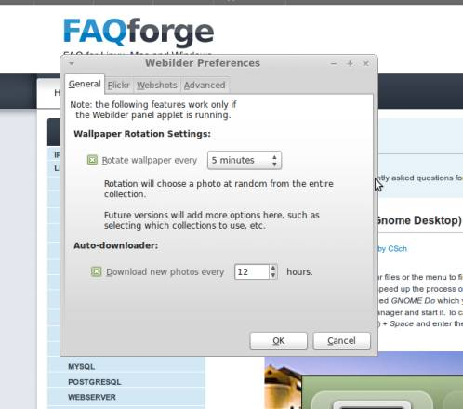](http://static.howtoforge.com/images/change_appearance_mint_advanced/big/1.jpg)](http://static.howtoforge.com/images/change_appearance_mint_advanced/big/1.jpg)

Here you can specify the intervals of rotation and download of wallpapers, which wallpapers should be downloaded and where they should be downoaded from. To add filters, head to the flickr tab, use the Add button and click on the filter fields to configure it.

[[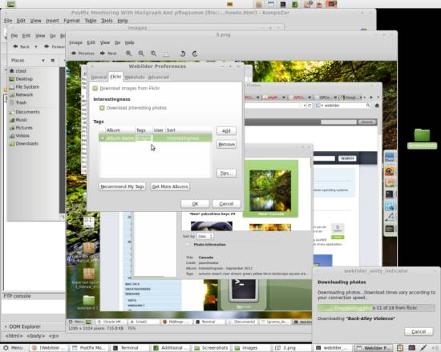](http://static.howtoforge.com/images/change_appearance_mint_advanced/big/4.jpg)](http://static.howtoforge.com/images/change_appearance_mint_advanced/big/4.jpg)

To browse the wallpapers already downloaded, leftclick the icon on the desktop panel again and choose Browse Photos. They are organized in recently downloaded photos and monthly categories, however you can also add your own albums:

[[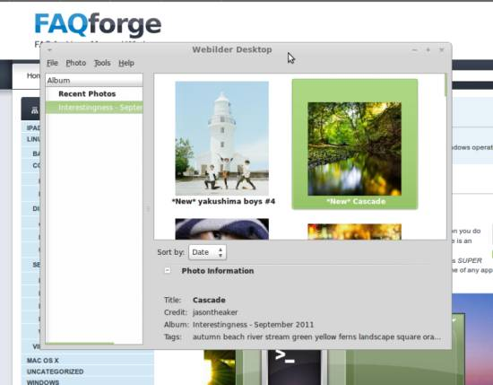](http://static.howtoforge.com/images/change_appearance_mint_advanced/big/2.jpg)](http://static.howtoforge.com/images/change_appearance_mint_advanced/big/2.jpg)

You can also delete, download and switch wallpapers manually by leftclicking the panel icon and selecting the appropriate action:

[[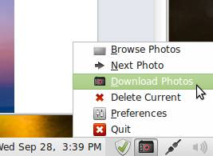](http://static.howtoforge.com/images/change_appearance_mint_advanced/big/3.jpg)](http://static.howtoforge.com/images/change_appearance_mint_advanced/big/3.jpg)

### 5 Install GNOME Color Chooser

GNOME Color Chooser is a tool that lets you modify the colors of your current theme. Either get it in the Synaptic Package Manager or enter the following into a terminal as root:

apt-get install gnome-color-chooser

[[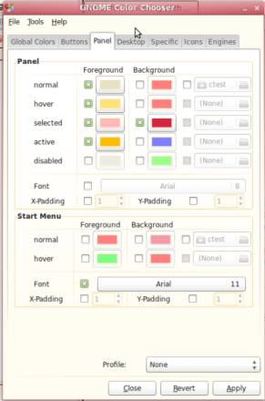](http://static.howtoforge.com/images/change_appearance_mint_advanced/big/5.jpg)](http://static.howtoforge.com/images/change_appearance_mint_advanced/big/5.jpg)

With this tool you have the option to apply the looks of your windows, menus, desktop icons, buttons and everything to the way you would like your desktop to look like. Simply run it through the Mint Menu, configure some colors, enable them, and click on Apply to see what they look like.

### 6 Install Docky

Docky is an Apple-like dock that is placable on any of the screens borders where you can put applications and folders onto to quick-access them. Remember that you need the nVidia proprietary drivers to do this!

*[[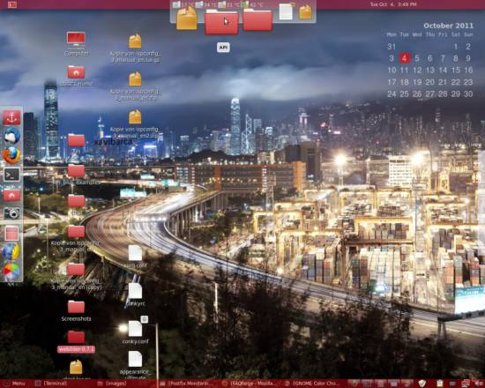](http://static.howtoforge.com/images/change_appearance_mint_advanced/big/6.jpg)](http://static.howtoforge.com/images/change_appearance_mint_advanced/big/6.jpg)*

To install, just access the Docky package in Synaptic Package Manager or enter following into a terminal as root:

apt-get install docky

On first startup there is not much placed in the dock, however there is a Docky icon with an anchor on it, which you can rightclick to configure it. To add new items to the dock, just drag and drop them onto it!

### 7 Install Screenlets

Screenlets are small visual applications comparable to widgets that you can place on your desktop to fulfill a certain function such as displaying time, processor load, calendar or the weather.

[[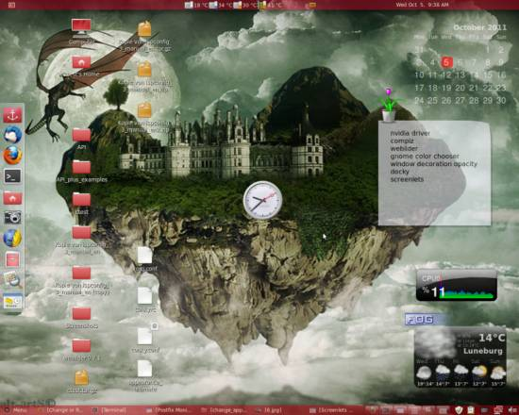](http://static.howtoforge.com/images/change_appearance_mint_advanced/big/7.jpg)](http://static.howtoforge.com/images/change_appearance_mint_advanced/big/7.jpg)

To install screenlets, either enter screenlets into Synaptic Package Manager's searchbar and follow the usual steps or enter

apt-get install screenlets

into a terminal logged in as root. On startup you will be shown a window with a selection of already preinstalled screenlets that you can instantly launch, however you also have the option to download new screenlets from the appropriate websites.

[[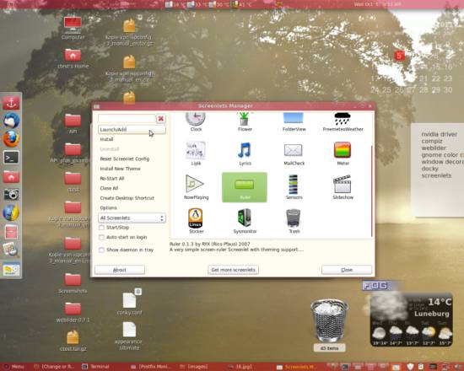](http://static.howtoforge.com/images/change_appearance_mint_advanced/big/8.jpg)](http://static.howtoforge.com/images/change_appearance_mint_advanced/big/8.jpg)

To add screenlets to your desktop, doubleclick them or select them and hit the Launch/Add button on the left. Then drag the screenlet to the location you want it to have. There you are free to Lock it by rightclicking and browsing the Window category. To install new screenlets, download the packed files from a website (such as [the GNOME screenlet website](http://gnome-look.org/index.php?xcontentmode=6700)) and click Install or Install New Theme to browse your files for the downloaded package.

### 8 Make The Panel's Opacity And Color Options Affect The Complete Panel

The default preferences of the control panel in the bottom of the screen allow you to either use a picture as its background image or to choose a color for it and lower its opacity if you use that action (access those by rightclicking free space on the panel and choosing Properties). If you color the panel however, not all elements of it will be colored but only the background, leaving all the buttons and backgrounds of panel icons grey.

[[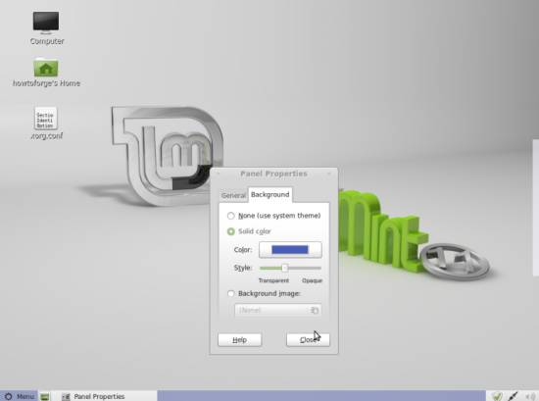](http://static.howtoforge.com/images/change_appearance_mint_advanced/big/9.jpg)](http://static.howtoforge.com/images/change_appearance_mint_advanced/big/9.jpg)

Now there is an option that allows you to configure the panel even more, which involves editing its configuration text file. For that, open /usr/share/themes/Mint-X-Metal/gtk-2.0/Apps/panel.rc and replace Mint-X-Metal with the theme you want your panel to configure in. Inside the panel.rc file there are three values that are set equal "Panel/panelbg.png". Find these and comment out their lines by placing a # in front of the whole line. Switch to another theme and back afterwards to reload your edited theme. Now the panel will look approximately like this:

[[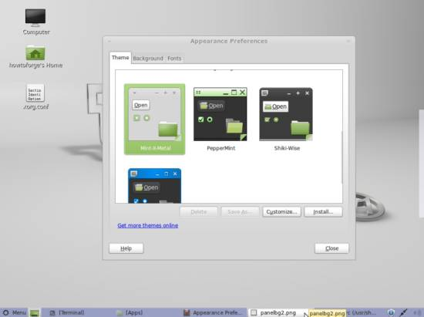](http://static.howtoforge.com/images/change_appearance_mint_advanced/big/10.jpg)](http://static.howtoforge.com/images/change_appearance_mint_advanced/big/10.jpg)

Although it has become more pleasing to the eye, there are still some annoying grey areas left if you use the Mint-X(-Metal) theme, while the others will look nice now. These areas originate from the imagefiles of the buttons, which are not completely transparent. The two options that you have if you still want to use one of these themes is to either disable the graphical buttons at all or to edit their borders to be completely transparent.

To disable the imagefiles of the buttons and display the tabs solely with their name and the application's icon, open the panel.rc file from before again and search the style sections for all values including Apps/Panel/button. Like before, comment the entire lines out by placing a # in front of them.

To make the borders of the button graphics transparent you will need to edit them manually with a graphical editor like The Gimp. The files are located in /usr/share/themes/Mint-X-Metal/gtk-2.0/Apps/Panel. Open them as administrator by rightclicking and choosing the appropriate action, then open them with an editor with the help of the control bar. Erase the colored transparent areas arount the actual buttons and save the files (The checkered area is the "table" beneath the image itself - it is only visible through transparent areas. You have to remove all color from the areas where this table shines through).

Then switch to another theme in the Control Center and back afterwards to use the updated theme. Your panel buttons should then either have their border removed or vanished completely, depending on which option you took.

[[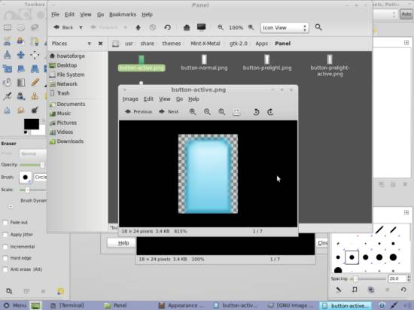](http://static.howtoforge.com/images/change_appearance_mint_advanced/big/11.jpg)](http://static.howtoforge.com/images/change_appearance_mint_advanced/big/11.jpg)

### 9 Lower The Window Decorations' Opacity

By using this option you achieve something that looks quite like the glassy look of window decorations that Microsoft Windows uses since its Vista Version. Remember that you need the nVidia proprietary drivers to do this!

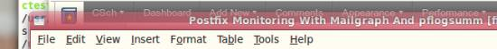

If you want your window decoration to be transparent, open a terminal and enter following as the user whose window decorations' opacity you want to lower (if it does not work properly you might have run it as root):

gconf-editor

A graphical user interface will appear that helps you to modify all kinds of keys. The ones you are searching for is under Apps > gwd.

[[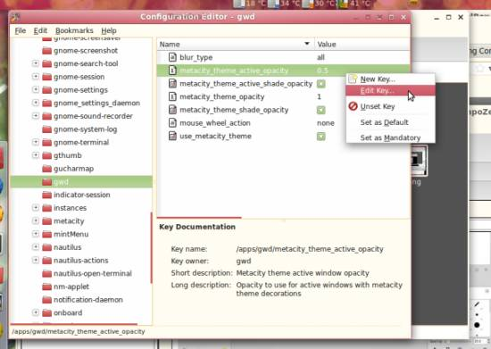](http://static.howtoforge.com/images/change_appearance_mint_advanced/big/13.jpg)](http://static.howtoforge.com/images/change_appearance_mint_advanced/big/13.jpg)

metacity_theme_active_opacity is the value for the currently active window, while metacity_theme_opacity is the value for all windows running in the background. Rightclick the keys and choose Edit Key... to change their values. You can select a number between 0 and 1, where 1 is full opacity and 0 is highly transparent.

Linux Mint Advanced Desktop (Results)

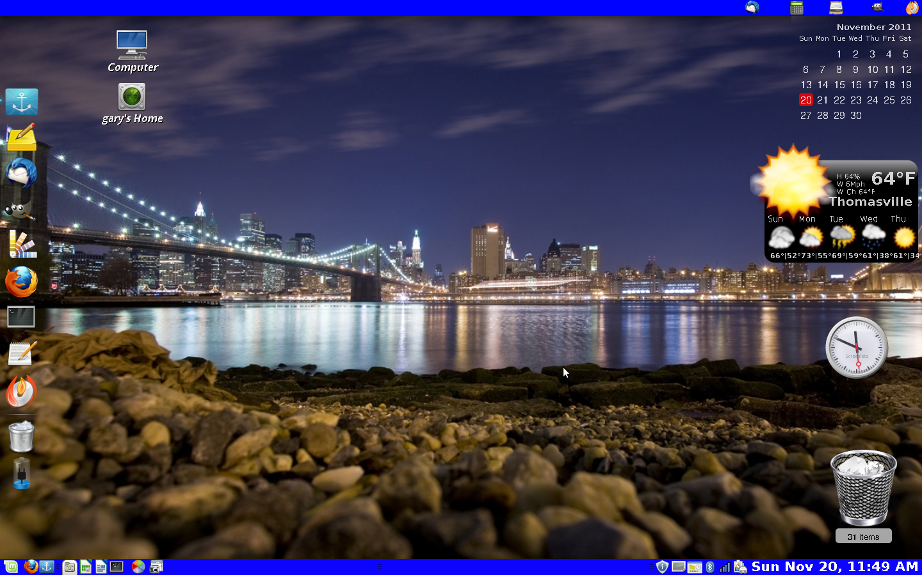

|  |  |  |  |  |  |  |  |  |
| --- | --- | --- | --- | --- | --- | --- | --- | --- |
|  |  |  |  |  |  |  |  |  |
|  |  |  |  |  |  |  |  |  |

**Journal Post (Mon. – Nov. 28,2011)**

Today we went over would we should expect to see on the final exam. The discussion intelled the “ls” command and the different aspects you can use it with.

ls = list directories

**ls ~**

List the contents of your home directory by adding a [tilde](http://www.computerhope.com/jargon/t/tilde.htm) after the ls command.

**ls /**

List the contents of your [root](http://www.computerhope.com/jargon/r/root.htm) directory.

**ls ../**

List the contents of the [parent directory](http://www.computerhope.com/jargon/p/parechil.htm).

**ls */**

List the contents of all sub directories.

**ls -d */**

Only list the directories in the current directory.

**Journal Post (Wed. – Nov. 30,2011)**

Today we continued to go over exam preparations. We discussed the following:

-bin = internal commands

-etc = config files

-vi /etc/network/interfaces > interfaces file

Apt-get install vim-nox > new version of vim

************Troubleshooting Network**********************

-/etc/init.d/networking start

-/etc/init.d/networking restart

-hostname = name of computer

To change hostname = hostname xxxxx

********************DNS*******************************

-to look at DNS file:

-cat /etc/resolv.conf

*************Networking Commands***********************

-ifconfig

-ping

-traceroute = must install traceroute program first

ethstatus .> network tool

*GUI Network Info*

System>network connections

*Terminal Network Info*

-vim /etc/network/interfaces

*change DHCP “static”

Address = 10.80.1.187

Gateway = 10.80.1.254

Netmask = 255.255.255.0

Network = 10.80.1.0

Broadcast = 10.80.1.255

Restart networking =” /etc/init.d/networking start”

du –disk usage

pwd = present working directory

ln –s vdir /var >= symbolic link (color red)

-this links the vdir directory to the /var directory

-“ls –l” >>> shows the priority of thr list